SOLENT UNIVERSITY
Faculty of Business, Law and Digital Technologies

BSc (Hons) Computer Systems and Networks Engineering

Dissertation Project COM616
Academic Year 2022-2023

“Wi-Fi 6 BSS colouring for residential areas”

Project report - Assignment AE2

Supervisor:
Date of submission: 5th May 2023

Acknowledgements

Abstract
Wi-Fi networks suffer from interference when there are other neighbouring Wi-Fi networks in the same vicinity, as networks overlap, interference could potentially degrade Wi-Fi network connectivity. In a residential scenario where neighbouring Wi-Fi networks are close together, there is greater potential for interference and network performance degradation. The Wi-Fi 6 (802.11ax) standard introduces the BSS colouring feature which attempts to tackle interference from other networks. A network device such as wireless routers or access points which provision the Wi-Fi connection for client devices and employ Wi-Fi 6 with BSS colouring; traffic between a wireless router or access point and its client devices within the same network would be tagged with a ‘colour’. With this technique, BSS colouring differentiates wireless traffic from one network to another, interesting traffic within one network can be focussed on, while foreign wireless traffic can be disregarded, in theory this would reduce interference from neighbouring Wi-Fi networks. This project had set out to test the extent in how much would residential Wi-Fi connectivity could be improved by utilising BSS colouring. The project had used NS3 simulations to test scenario deployments of close quarter residential environments, with neighbouring Wi-Fi networks close to each other. The simulation tests conducted had revealed that within a close quarter residential environment, with Wi-Fi networks 10-meters apart, BSS colouring had made no difference in throughput performance of the networks, regardless of if BSS colouring was enabled or disabled. However, when the Wi-Fi networks were positioned further apart, 75-meters apart, then BSS colouring had improved throughput performance by up to 69.38%. The project had faced problems when utilising the NS3 simulator, an ideal residential environment was not possible to be scripted and the ideal granular results were not possible to be obtained. Therefore, the results which were generated were unfortunately considered inconclusive.

Contents
Acknowledgements 1
Abstract 2
Acronyms 5
Wi-Fi Alliance name and IEEE wireless standard name 5
Word count 5
Table of figures 6
Figures 6
Tables 8
1. Introduction 9
1.1 Project 9
1.2 Problem 9
1.3 Research question 10
2. Literature review 11
2.1 Wi-Fi 6 BSS colouring 11
2.2 Testing method 12
2.3 Conventional testing parameters 13
3. Project specification 16
3.1 What is the project Artefact 16
3.2 What was needed for the project 16
3.3 List of requirements 17
3.4 Outcome 19
3.5 What could be done if more time was granted 19
4. Methodology 20
4.1 Data gathering 20
4.2 Professional, Legal and Ethical issues 20
4.3 Methods 21
4.3.1 Simulation and test parameters 21
4.3.2 Tests 1, 2, 3, 4 – Main tests related to Research Question 21
4.3.3 Tests 5, 6, 7, 8 – Additional sanity check and validation tests 22
4.4 Project management 22
4.4.1 First task 22
4.4.2 Second task 23
4.4.3 Third task 23
4.4.4 Deviation from original project aims 24
5. Design & implementation 25
5.1 Main tests – Tests 1, 2, 3, 4 25
5.1.1 Tests 1 & 2 27
5.1.2 Tests 3 & 4 29
5.2 Sanity check tests – Tests 5, 6, 7, 8 31
5.2.1 Tests 5 & 6 33
5.2.2 Tests 7 & 8 33
5.3 Problems that arose 34
5.3.1 The problems 34
5.3.2 Initial attempts to resolve problems 34
5.3.3 Final attempts to resolve problems – Project supervisor meeting 35
6. Results 36
6.1 Main tests results – Tests 1 & 2, tests 3 & 4 37
Tests 1 & 2 results summarisation and evaluation 37
Tests 3 & 4 results summarisation and evaluation 38
6.2 Sanity check tests results – Tests 5 & 6, tests 7 & 8 39
Tests 5 & 6 results summarisation and evaluation 39
Tests 7 & 8 results summarisation and evaluation 40
7. Conclusion 41
8. Recommendations for further work 42
References 43
Bibliography 45
Appendices 47
Appendix A – Ethics release 47
Appendix B – Modified script 50
Appendix C – Original unmodified script 64
Appendix D – Commands used in test simulations and result outputs 72

Acronyms
Acronym | Description
AP | Access point
BSS | Basic service set
CCA | Clear channel assessment
CLI | Command line interface
dBm | Decibel-milliwatt
GHz | Gigahertz
Mbits/s | Megabits per second
MHz | Megahertz
OBSS | Overlapping basic service set
OBSS/PD | Overlapping basic service set/Preamble-detection
IEEE | Institute of electrical and electronics engineers
STA | Station
SR | Spatial reuse
SRG | Spatial reuse group
tx | Transmit
WLAN | Wireless local area network
XML | Extensible Markup Language

Wi-Fi Alliance name and IEEE wireless standard name
Wi-Fi Alliance name | IEEE wireless standard name
Wi-Fi 6 | 802.11ax

Word count
Report main body word count (sections 1-8), excluding headings, tables, and captions:
9921

Table of figures

Figures
Figure 1. Homogeneous deployment for small BSSs that can be overlapped with each other. Deployment for general scenarios and use cases: E-education, Wireless office, Stadium, etc (Kim, et al., 2013). 14

Figure 2. IEEE TGax residential WLANs simulation scenario, apartment building floor with neighbouring apartments (Merlin, et al., 2015). 15

Figure 3. BSS colouring residential simulation deployment environment with distances between APs and STAs from existing research (Wilhelmi, et al., 2021). 15

Figure 4. Residential OBSSs with BSS colouring test parameters, Toy scenario 2 parameters represent parameters for residential simulation (Wilhelmi, et al., 2021). 18

Figure 5. TP-Link AX1800 Wi-Fi 6 wireless router interface settings for 5Ghz band examined. 18

Figure 6. Simulation tests were repeated twice during the implementation of the project. The NS3 simulator returned repeatable results if identical parameters were used. 20

Figure 7. Spacing and distance parameters between AP and STA devices of each BSS in the main tests: tests 1, 2, 3, 4. Spacing between devices are determined by positioning parameters shown in the figure. 26

Figure 8. Diagram of simulation spacing set-up for main tests 1 & 2 in a residential environment scenario. STAs are positioned close together to force a OBSSs scenario, while staying in their respective BSS and residential square. 27

Figure 9. Grid co-ordinates visualisation for main tests 1 & 2 in a residential environment scenario. STAs are positioned close together to force a OBSSs scenario, while staying in their respective BSS and residential square. 28

Figure 10. Main tests 1 & 2 NS3 simulations executed in the terminal CLI with generated results. BSS colouring is enabled in test 1 with "--enableObssPd=True" command, and BSS colouring disabled in test 2 with "--enableObssPd=False" command. 28

Figure 11. Diagram of simulation spacing set-up for main tests 3 & 4 in a residential environment scenario. STAs are positioned apart from each other to create a less harsh OBSSs scenario, while staying in their respective BSS and residential square. 29
Figure 12. Grid co-ordinates visualisation for main tests 3 & 4 in a residential environment scenario. STAs are positioned apart from each other to create a less harsh OBSSs scenario, while staying in their respective BSS and residential square. 30

Figure 13. Main tests 3 & 4 NS3 simulations executed in the terminal CLI with generated results. BSS colouring is enabled in test 3 with "--enableObssPd=True" command, and BSS colouring disabled in test 3 with "--enableObssPd=False" command. 30

Figure 14. Diagram of simulation spacing set-up for sanity tests 5 & 6, and tests 7 & 8. Tests 5 & 6 follow conventional residential 10x10-meter square spacing parameters, tests 7 & 8 are 75m apart and beyond conventional parameters. 32

Figure 15. Grid co-ordinates visualisation for sanity check tests 5 & 6, and tests 7 & 8. Tests 5 & 6 follow conventional residential 10x10-meter square spacing parameters, tests 7 & 8 are 75m apart and beyond conventional parameters. 32

Figure 16. Sanity check tests 5 & 6 NS3 simulations executed in the terminal CLI with generated results. BSS colouring is enabled in test 5 with "--enableObssPd=True" command, and BSS colouring disabled in test 6 with "--enableObssPd=False" command. 33

Figure 17. Sanity check tests 7 & 8 NS3 simulations executed in the terminal CLI with generated results. BSS colouring is enabled in test 7 with "--enableObssPd=True" command, and BSS colouring disabled in test 8 with "--enableObssPd=False" command. 33

Figure 18. Bar chart displaying visualisation for results gathered in main tests 1 & 2, when STAs positioned close together. No difference in throughput performance with BSS colouring feature enabled or disabled, behaviour of BSSs have minimum maximum throughputs. 37

Figure 19. Bar chart displaying visualisation for results gathered in main tests 3 & 4, when STAs positioned apart from each other. No difference in throughput performance with BSS colouring feature enabled or disabled, and behaviour of BSSs have the same throughputs. 38

Figure 20. Bar chart displaying visualisation for results gathered in sanity check tests 5 & 6, when STAs positioned 5m away from APs and APs 10m apart. No difference in throughput performance with BSS colouring feature enabled or disabled, behaviour of BSSs have minimum maximum throughputs. 39

Figure 21. Bar chart displaying visualisation for results gathered in sanity check tests 5 & 6, when STAs positioned 5m away from APs and APs 75m apart. BSS colouring enabled when APs of BSSs placed further apart benefits throughput performance. 40

Tables
Table 1. Initial gathered test simulations device transmission power and sensitivity threshold parameters to be used in project. 18

Table 2. Simulation test parameters for the main tests: tests 1, 2, 3, 4. 26

Table 3. Simulation test parameters for the sanity check tests: tests 5, 6, 7, 8. All sanity check test parameters are identical to those use in the main tests: tests 3 & 4, apart from the AP distance in tests 7 & 8. 31

Table 4. All results from project test simulations, main tests results and sanity check tests results. 36

1. Introduction

1.1 Project
This project created test residential environment network simulations which consisted of overlapping wireless local area networks (WLANs), each WLAN was populated with an access point (AP) and a wireless end device client; known as a station (STA). The combination of an AP and client STAs within the same WLAN make up a basic service set (BSS). Overlapping basic service sets (OBSSs) were simulated, where three BSSs were within proximity to another.
The project simulation aimed to test how much would the OBSS management feature: BSS colouring of Wi-Fi 6 (802.11ax), would improve wireless connectivity for a residential area when it is enabled, compared to when it is disabled. Quantitative performance throughput data metrics were obtained from the simulations to form the comparison between Wi-Fi 6 with BSS colouring enabled and disabled.

1.2 Problem
According to research by (Lean, 2022) on high-speed internet for daily life which include use cases for residents, findings of various activities using the connection are split into two categories: general and particular. General: emails, social media, online shopping, entertainment, etc. Particular: hobbies, online tutorials & learning, homework online, working from home, etc. However, the experience of some of these activities can depend on the quality of residential WLAN connectivity which could be affected by the wireless home router or access point (AP), due to interference. Reiterated by (Hoffman, 2017), residential neighbourhoods with multiple properties that have multiple WLANs which are in the vicinity of one another, the probability of Wi-Fi interference and WLAN performance degradation is increased.
Home wireless routers or APs that utilise older standards may be more prone to interference from neighbouring networks and therefore somewhat affect user experience. Findings from (Kosek-Szott, et al., 2017) on previous generations of Wi-Fi standards state that, “while OBSS management was designed for networks operating on the same channel… an extension of this functionality is required due to the possibility of significant interference between networks operating on disjoint frequency channels”. This implies that a form infant of OBSS management was present in older generations of Wi-Fi, however it lacks the ability to deal with interference from neighbouring BSSs. Residential users who live in denser populated areas and properties such as apartment blocks would more likely be affected by Wi-Fi interference leading to WLAN performance drops, due to other wireless routers and APs which are operating within close proximity in neighbouring properties.
However, wireless routers and APs which utilise the recent Wi-Fi 6 standard, with its BSS colouring feature, may mitigate interference inconveniences significantly from OBSSs. Reinforced by Wi-Fi 6 BSS colouring summary test results by (Malhotra, et al., 2019), “our results show that dynamic CCA [clear channel assessment] threshold adaptation improves the aggregate throughput by (50-79%) when the distance between the two BSSs is set to 100. 0 m.”. This result summary gives an answer to the problem of OBSS interference, which in turn gives the impression that BSS colouring may be a possible solution to residential OBSSs interference too. However, Malhotra emphasises that the positive results were due to spacing two BSSs to 100-meters apart. This forms the bases for the project in finding out how much would BSS colouring from Wi-Fi 6 would benefit residential WLAN connectivity where BSSs would be closer together.

1.3 Research question
To what extent would residential wireless local area network (WLAN) connectivity; throughput, be improved by the utilisation of BSS colouring derived from Wi-Fi 6 (IEEE 802.11ax)?

2. Literature review

2.1 Wi-Fi 6 BSS colouring
BSS colouring is a feature of Wi-Fi 6 that aims to mitigate interference issues from neighbouring BSSs which overlap each other, this is known as spatial reuse. By mitigating interference issues the WLAN performance of BSSs could be, in theory, improved. According to (Selinis, et al., 2018), “IEEE 802.11ax Spatial Reuse (SR) is… aiming at improving the spectrum efficiency and the network performance in dense deployments. The main and perhaps the only SR technique in that amendment is the Basic Service Set (BSS) Color”. This finding backs up the principle that within one BSS, traffic between the AP and its STAs would likely be identified by a colour to differentiate traffic of one BSS to any other BSSs traffic within the area; BSS colouring acting as the OBSS interference management mechanism. An analysis of BSS colouring by (Natkaniec & Bieryt, 2022) further backs up the functionality of BSS colouring, “It makes it possible to distinguish transmissions from different Basic Service Set (BSS) areas, taking place on the same channel, by color”. This puts more emphasises on BSS colouring, the ability to tag traffic within its operating BSS with a colour, to depict and focus on the interesting traffic from its own network while able to ignore foreign traffic from other BSSs nearby. Although this is a simplified look at BSS colouring, due to the nature of its operation within Wi-Fi 6, it should theoretically improve WLAN performance by mitigating interference issues by OBSSs.
To support the need for BSS colouring, previous Wi-Fi standards lacked an adequate form of OBSS management which was problematic to WLAN performance. Discoveries from (Kosek-Szott, et al., 2017) on co-existing Wi-Fi networks discover that “self-configuration in terms of channel frequency… as well as adaptive channel sensing (currently being considered by TGax) constitute a strong requirement for future Wi-Fi deployments”, “otherwise, poor network performance is inevitable, especially if networks are operating in close proximity”. This suggests that older Wi-Fi standards before the entry of Wi-Fi 6 lacked a robust OBSS management system to counter interference from OBSSs. Hypothetically, in relation to the use case of the project, multiple residential OBSSs which employ APs which utilise a Wi-Fi standard without a robust OBSS management system could suggest residential users may have their WLAN performance negatively impacted. However, fortunately BSS colouring from Wi-Fi 6 aims to tackle the problem.
BSS colouring can improve WLAN connectivity by mitigating interference. Tests by (Selinis, et al., 2018) which compared legacy BSS management to Wi-Fi 6 BSS colouring revealed that “simulation results in various scenarios, show a clear performance improvement of up to 57% gain in throughput over a conservative fixed OBSS/PD for the legacy BSS Color”. This test result summary indicates that BSS colouring increases WLAN performance of a BSS. In relation to the research question, this result published by Selinis gives an early indication that BSS colouring has potential to improve WLAN performance of a BSS compared to a BSS that is not employing BSS colouring. Also, Selinis has presented throughput as a test result metric. For this project, throughput would also be a sound measurement metric for test results and comparisons.
To reinforce the beneficial BSS colouring network performance premise, BSS colouring tests by (Malhotra, et al., 2019) reveal that, “our results show that dynamic CCA [clear channel assessment] threshold adaptation improves the aggregate throughput by (50-79%) when the distance between the two BSSs is set to 100. 0 m.”. This test result reinforces and validates the results presented by Selinis in the previous paragraph, as well as showing the working functionality of BSS colouring. However, in relation to the research question and project, in Malhotra’s test BSSs were spaced 100-meters apart. That distance between the APs within the BSSs can be considered too far apart when depicting a residential environment, where buildings or apartments with operating BSSs are likely to be much closer together. The results in Malhotra’s test environment also give an early positive indication for network throughput performance using BSS colouring within a residential environment. However, the extent of that would need to be answered by the results to the research question and project by utilising a simulation environment which employs tighter spacing between BSSs.
To contradict the positive performance claims of BSS colouring, WLANs with BSS colouring implemented in smaller spaces may still suffer performance losses due to interference. BSS colouring test analysis carried out in a close quarter residential environment by (Wilhelmi, et al., 2021) states that, “As a result of the complex inter-BSS interactions taking place in this deployment, the throughput functions are non-convex and contain different local minimum/maximum. This reveals the competitive nature of this deployment, where BSSs’ individual performance is sometimes maximized at the expense of reducing the others’ throughput.”. The test environment which Wilhelmi used can be seen in Figure 3 below. From this analysis, the performance of a BSS could still be negatively impacted by another BSS due to colouring and its competitive wireless functionality. The previous early indications of BSS colouring point towards the impression that if all BSSs utilised BSS colouring, wireless interference could be somewhat be ignored due to a BSS employing the ability to focus on its own-coloured traffic and therefore improve WLAN performance. However, the analysis presented by Wilhelmi changes some expectations of BSS colouring performance of the project, while one BSS may excel in throughput performance, another may suffer slightly due to the still persistent problem of signal competitiveness. The results produced from the project may or may not back up the positive or problematic claims of utilising BSS colouring to answer the research question.

2.2 Testing method
Of the existing research reviewed up to this point in the literature review, simulation of the Wi-Fi 6 networks and BSS colouring scenarios seem to be the standard method of conducting such tests. Tests by (Selinis, et al., 2018) state that, “This work presents an evaluation of the aforementioned schemes in a high-density wireless network, using NS3 simulation tool”. While for experiments by (Malhotra, et al., 2019), “We have used ns-3 to simulate a variety of real networks”. Both tests carried out on wireless networks in these two research journals were implemented by using the NS3 simulator, which acts as a form of inspiration for the simulator to use for the project. However, upon further findings of more recent experiments by (Wilhelmi, et al., 2021) state that, “We analytically model the 11ax SR operation for the sake of capturing and understanding the new kinds of inter-BSS interactions that result from it. The results of this model are verified with the Komondor 11ax-based simulator.”. In this research, the Komondor simulator was utilised. All three research journals had a mention of utilising a simulator for testing. This perhaps suggests that employing a simulator could be an option used to carry out the project tests. It could also be a part of the project requirements and methodologies, following methodologies and conventions from other researchers. The mention of the NS3 and Komondor simulators will need to be evaluated later in the project specification so that the appropriate simulator can be selected.
To support the use of a simulator for the project, while it is possible to utilise real hardware to test Wi-Fi 6 BSS colouring, it would come with several challenges. Real world environments have too many variables, such as natural interference, space, and feasibility could alter test results. Research by (Rachedi, et al., 2010) on wireless network tests in the real world compared to using a simulator emphasises that “the impact of some parameters such as: the type of environment (indoor/outdoor) the terminal location and movement are very important and can inﬂuence the performance evaluation of protocols or models”. In the context of a research test environment, the various parameters that may affect the end results could lead to a project to produce incorrect results for the purpose of the project, such as the project of this literature review. Moreover, the cost and feasibility of hardware, or space required could also be a problem. Additionally, (Rachedi, et al., 2010) also states, “the study shows that the simulation results can be rather close to the experimental results”. This points towards that, to test a wireless network environment, it is perhaps more feasible to utilise a simulator to produce real-world relating results. On the other hand, it could also be considered that to perhaps produce the most accurate, real-life scenario results, it may be suitable to use real hardware in that case. However, for the purposes of this project, a simulator would be more feasible.

2.3 Conventional testing parameters
To form an idea of the project simulation and test environment parameters, early exploration into existing literature on simulation scenarios for small BSS deployments reveals some guidance, which loosely relate to residential environments. A conference proceeding in 2013 by (Kim, et al., 2013) suggests that a scenario deployment which consists of small neighbouring BSSs for wireless network design could be implemented in a 40-meter by 40-meter area with APs 20-meters apart, as seen below in Figure 1. This recommended deployment gives some idea on how to configure the spacing parameters between APs and STAs in the project; APs and STAs to be housed within a square area without exceeding the borders of that area. This idea is logical, as the limited set area will contain a certain number of BSSs which will likely force the scenario of OBSSs, which is needed for the project. However, the problem with the test deployment scenario area in Figure 1 is that it is too large to adopt for the project, the 40-meter by 40-meter area is questionably large for a residential environment. The use cases for the deployment in Figure 1 are: “E-education, Wireless office, Stadium, etc.”, as stated by (Kim, et al., 2013). The intended use cases for the set-up in Figure 1 are beyond residential use cases, therefore not suitable for the project. However, the deployment scenario area recommendation gives some clues on simulation area size parameters; a square area which contains OBSSs and position of APs.
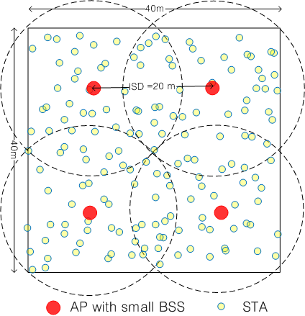
Figure 1. Homogeneous deployment for small BSSs that can be overlapped with each other. Deployment for general scenarios and use cases: E-education, Wireless office, Stadium, etc (Kim, et al., 2013).

To further build on the foundation of the project simulation environment, further exploration into existing projects reveal more targeted information in relation to the residential scenario of the project. Research and project documentation by (Merlin, et al., 2015) on IEEE WLANs simulations reveal a direct simulation scenario for residential scenarios, which consists of an apartment building floor, each apartment square being 10-meters by 10-meters, as seen in Figure 2. The 10-meter by 10-meter residential apartment square representation is sounder for the project residential use case compared to the scenario which was previously explored in Figure 1. With the residential scenario set in Figure 2, the project could follow existing conventional residential environment size parameters set by other projects. Recommendations by (Merlin, et al., 2015) in relation to Figure 2, states that “in each apartment, place AP in random xy-locations” and “in each apartment, place STAs in random xy-locations”. The recommended placement of APs and STAs within an apartment square gives the project flexibility in AP and STA placement within the simulation, as no strict placement recommendation is mentioned. From this, the project will likely follow the conventional residential spacing parameters set by Merlin. However, apartment APs could perhaps have a fixed distance to neighboring apartments in the project simulations, while remaining within the boundaries of the 10-meter by 10-meter apartment square. The distance between APs will be decided later in the project and will follow conventional distance parameters provided in Figure 2.
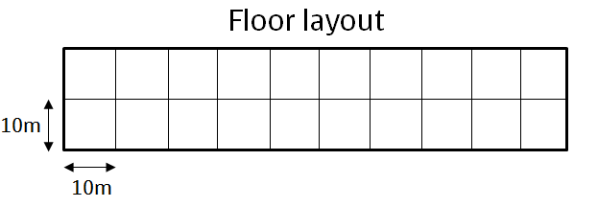
Figure 2. IEEE TGax residential WLANs simulation scenario, apartment building floor with neighbouring apartments (Merlin, et al., 2015).

To validate the simulation environmental spacing parameters set by Merlin in Figure 2, an existing research project on BSS colouring by (Wilhelmi, et al., 2021) has simulated a residential environment OBSSs that follow those parameters, seen in Figure 3. Each of the 4 and 5.4-meter spacing between the APs are within the boundaries of the spacing parameters in Figure 2. In addition to the conventional spacing parameters between APs, the spacing between STAs are also seen at 4-meters away from the AP. This makes logical sense for a residential environment, such as an apartment, as residential users are likely to not stray far away from their AP or wireless router while staying in their property. This also provides some inspiration for the project simulation in STA placement in relation to their associated AP, this will be explored later in the project. Moreover, Figure 3 as a diagram is consise in how it portrays OBSSs within the given area; each BSS differentiated from one another. This provides some insight into the artefacts that could be created for the project simulations later.
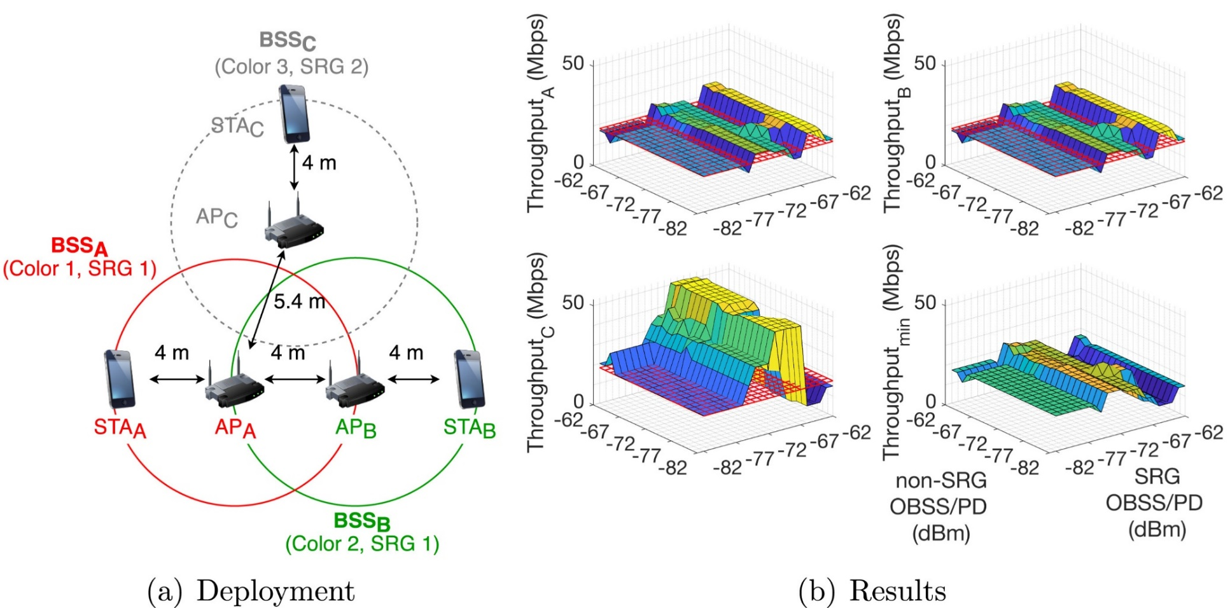
Figure 3. BSS colouring residential simulation deployment environment with distances between APs and STAs from existing research (Wilhelmi, et al., 2021).

3. Project specification

3.1 What is the project Artefact
The main artefact of this project is a set of bar graphs that showcase a summary of quantitative throughput results that were obtained towards the end of the project from residential environment Wi-Fi 6 BSS colouring simulations. Each bar chart represents throughput results that were gathered from different simulation tests, each bar chart included results from tests that had BSS colouring enabled and disabled.
Furthermore, there are several supporting artefacts which gives context to the test simulation environments used to obtain the test results. The modified script that was used to run the simulations can be found in Appendix B – Modified script, comments within the code describe the functionality of the script. Also, screenshots of command line interface (CLI) inputs show the parameters which were used by the simulation scenarios, as well as tables which summarise the parameters used for the project simulations. Additional plot graphs and diagrams will showcase the scripted topology for the simulation scenarios and distance between devices, created graphics will also support the visualisation of the simulation scenarios.

3.2 What was needed for the project
The NS3 simulator was the main tool that was needed to conduct the simulations and generate results for the project. NS3 is a Linux CLI based network simulator which creates simulation environments for networking research, it supports wireless simulations which include Wi-Fi (Nsnam, 2023). There are other simulators which would suit the purposes of the project, such as the Komondor network simulator. According to (Barrachina-Muñoz, et al., 2019), “Komondor is a wireless network simulator for next-generation wireless local area networks (WLANs). The simulator has been conceived as an accessible (ready-to-use) open-source tool for research on wireless networks and academia.”. However, upon searching for tutorials and documentation for the Komondor simulator, there was a lack of tutorials and documentation available for the simulator. On the other hand, NS3 tutorials and documentation were more widely available compared to Komondor. Therefore, the NS3 was chosen for the project. Even though NS3 tutorials were available, there were only a handful of tutorials which related to the needs of the project, but NS3 tutorial content was more widely available compared to Komondor tutorials. Although there was tutorials and documentation available for NS3, it was still niche software.
There are some prerequisites which were required when using NS3 for the project, NS3 is Linux based software and simulations are run by executing scripts in the terminal CLI, that are written in the C++ programming language, in the Linux terminal CLI (Nsnam, 2023). From these pre-requisites, an Ubuntu Linux virtual machine was set up for the project. NS3 was installed on the Ubuntu virtual machine by following a tutorial from (Kumar, 2022). Visual Studio Code was also installed on the virtual machine, which was used as the integrated development environment to edit scripts for the NS3 simulator.
After the pre-requisite software were in place, the next challenge was to provide the simulator with a script to run. NS3 utilises scripts, which are written in C++ to run its simulations. Therefore, an existing example script provided in NS3, written by (Deronne, 2019), which lays out a simulation scenario on testing throughput of two OBSSs when BSS colouring is enabled, was modified and used for the project. The modified script can be seen in Appendix B – Modified script. An existing script was modified and used for the project as participating members of the project had little experience with programming in C++, this was also justified with the nature of the project being a networking project rather than a coding project. The modifications of the modified script will be discussed later in the report.
Results which were generated by simulations were stored in a spreadsheet for documentation, as well as to produce results summarisation graphs to create the artefacts of the project.

3.3 List of requirements
The base simulation scenario environment would need to follow the spacing convention that was discovered in Figure 2 above. The convention for one residential apartment is 10-meters by 10-meters, and “in each apartment, place AP within random xy-locations… place STAs in within random xy-locations”, as stated by (Merlin, et al., 2015). The placement between APs should not exceed a 20-meter boundary due to the nature of simulating two apartments which would be next to each other. On the other hand, STAs should be within the 10-meter by 10-meter boundary of an apartment square. With the spacing convention in place, two or more residential apartments would ideally be needed to form the simulation scenarios, to form the neighbouring OBSSs from neighbouring apartments.
Additionally, testing parameters such as device transmit powers and sensitivity thresholds should also follow conventional examples that have been used in existing research. Within the literature review, an existing sample of residential BSS colouring testing was explored. The parameters that (Wilhelmi, et al., 2021) had utilised for their residential environment BSS colouring test can been seen in Figure 4 under “Toy scenario 2”. While taking early looks into a suitable script that can be modified for the project, which can be seen in Appendix C – Original unmodified script, the “default tx power[dBm]” 20 parameter can be cross referenced with the default AP transmit power within the original script. The transmit power of STAs is not mentioned, but in the original script it is set to 10dBm, to give the best chance for client STA devices, it will be raised to 12dBm for the project. The “default CCA/CS[dBm]” -82 parameter can be applied to all APs and STAs due to APs and STAs within the original script using the same value. Moreover, (Wilhelmi, et al., 2021) mentions “BSSs use… SRG OBSS/PD = -73 dBm” for the sensitivity of BSS colouring settings, which will also be used for this project, this value cross references and is close to the value set in the original script. In addition to conventional parameters used by previous research, to decide on the channel bandwidth to use, 5GHz band settings on a TP-Link AX1800 Wi-Fi 6 home wireless router was examined, as seen in Figure 5. Due to the “Auto” setting on bandwidth selection, the 40MHz parameter was selected as a middleground to use for the project simulations. A summary of all gathered transmit powers and sensitivity threshold requirements can be found in Table 1.
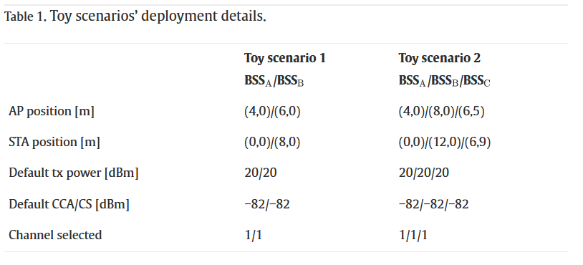
Figure 4. Residential OBSSs with BSS colouring test parameters, Toy scenario 2 parameters represent parameters for residential simulation (Wilhelmi, et al., 2021).

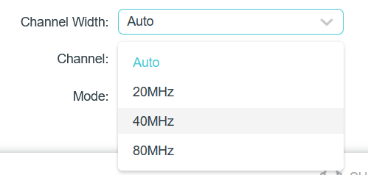
Figure 5. TP-Link AX1800 Wi-Fi 6 wireless router interface settings for 5Ghz band examined.

Parameter | Value
GHz band and channel bandwidth | 5GHz / 40MHz
STA tx power | 12 dBm
AP tx power | 20 dBm
CCA threshold for APs and STAs | -82 dBm
OBSS/PD | -73 dBm
Table 1. Initial gathered test simulations device transmission power and sensitivity threshold parameters to be used in project.

3.4 Outcome
The expected outcome of this project was that simulations with BSS colouring enabled would produce better throughput results compared to simulation with BSS colouring disabled, due to the purpose of BSS colouring to reduce interference from OBSSs. These results would answer the research question, to what extent would BSS colouring would improve connectivity for residential environments. However, the quantitative results gathered were surprising, but also backed the theory of (Wilhelmi, et al., 2021), where BSS colouring WLANs have a competitive nature which affects the performance of other BSSs, and may not improve residential WLAN performance across the board as first expected.

3.5 What could be done if more time was granted
If a generous amount of more time was to be given for the project from the start, more time could be spent on learning the C++ programming language. This would perhaps allow for a more proficient script to be written for the NS3 simulator, compared to modifying the existing script which caused several complications for the project progress. Additionally, as a hindsight, if the project were to be granted a budget, then testing could perhaps have been carried out with real hardware. This would be costly and may be hindered by an unlimited amount of natural interference from the real world, but this approach could also be considered to produce the relatable results to a real residential environment.

4. Methodology

4.1 Data gathering
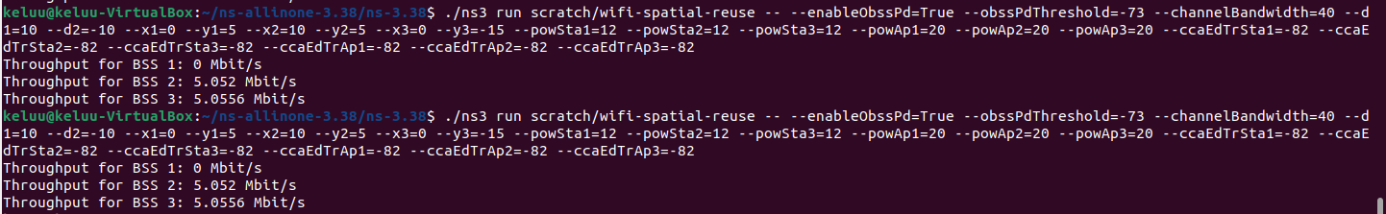
The quantitative data measurement metric which was gathered from this project were throughput metrics, obtained from the simulation tests. The results which were produced from the NS3 simulator were repeatable. Identical throughput results were produced from running simulation scenarios twice for each test conducted in the project, as shown in Figure 6. The data sets which were gathered from the project NS3 simulations, were not large in nature. Therefore, it was feasible to store the gathered results manually in a spreadsheet for analysis and to produce data summarisation and visualisation graphs, which can be found in the 6. Results section of the report.
Figure 6. Simulation tests were repeated twice during the implementation of the project. The NS3 simulator returned repeatable results if identical parameters were used.

However, the original intention to gather data was to iterate through an XML output file produced for each simulation and create graphs using a python script and the matplotlib library. Unfortunately, during the implementation stage of the project, difficulties arose which had not made that possible; discussed more in the 5.3 Problems that arose section of the report. In addition, the conclusiveness of results may also be impacted due to challenges faced with the implementation of the project.

4.2 Professional, Legal and Ethical issues
The nature of this project does not conflict with any major ethical issues, due to the use of the NS3 simulator. No vulnerable or sensitive human or real entity was required during all stages of the project. The data gathered during the project were from a simulated virtual environment. The simulated residential environment for testing residential Wi-Fi connectivity, does not depict any real-world location. Furthermore, the NS3 simulator is a CLI based software, which further restricts the visualisation of any real-world location. The project also had no financial issues due to the use of the NS3 simulator, where hardware was simulated within the virtual environment. The ethical release of this project can be found in Appendix A – Ethics release.
The original script which was adapted and modified for the project is licensed under the GNU General Public License version 2, which allows this project the ability to modify or redistribute the script. The modified script used within this project has been credited to the author of the original unmodified script. The modified script can be found in Appendix B – Modified script and the original script in Appendix C – Original unmodified script (Deronne, 2019).
Regarding professional issues, the project was under supervision. Any time which an issue arose, the supervisor was contacted for feedback and advice on how to proceed. Supervision meetings were not documented, but when the project faced problems, mentioned in the 5.3.3 Final attempts to resolve problems – Project supervisor meeting, a meeting was organised with the supervisor to attempt to address these problems so that the project may proceed.

4.3 Methods

4.3.1 Simulation and test parameters
Using a network simulator such as NS3 for the project benefits the project due to its functionality. The simulated network environment(s) constructed allows the researcher to make changes to systems and features of a network scenario to observe the behavioural changes and gather statistics of the system(s) for further study (Nsnam, 2019).
To create simulation scenarios within the NS3 simulator which best relate to the residential use case of the research question and residential conventional spacing parameters reiterated by (Merlin, et al., 2015), test scenarios were set up with three BSSs which were housed within separate 10-meter by 10-meter square boarders, representing separate apartment squares, as seen in Figure 8 and Figure 11 below. Each apartment square housed an AP and a STA which formed one BSS. Neighbouring apartment squares will force the OBSS scenario for the simulation tests. Additionally, the initial conventional gathered device transmission powers and sensitivity threshold parameters used by (Wilhelmi, et al., 2021), seen in Table 1 (above) in their project was also integrated into this project.
The tests which were carried out in this project had generated WLAN traffic with the BSS colouring parameter alternate between enabled and disabled for different tests. This allowed for the observation of WLAN performance behaviours of BSSs when BSS colouring was enabled or disabled in a residential setting. The justification for this is because, in the real world, various off-the-shelf consumer Wi-Fi 6 home wireless routers for residential environments either featured BSS colouring or not. For example, the TP-Link Deco X50 wireless router features BSS colouring (TP-Link, 2023), whereas the TP-Link Archer AX20 wireless router does not feature BSS colouring (TP-Link, 2023). In testing Wi-Fi 6 residential scenarios with BSS colouring enabled and disabled worked towards the object of answering the research question.

4.3.2 Tests 1, 2, 3, 4 – Main tests related to Research Question
A total of 4 tests were carried out which were in relation to the residential use case of the research question, these tests ran from the base deployment scenario which were set up in the modified script. The modified script can be seen in Appendix B – Modified script. The topology spacing, distance and positioning set-up for each AP of a BSS, for each test scenario were identical; 10-meters apart from each other. On the other hand, the spacing parameters which changed were the spacing and positioning of the STA mobile devices of each BSS. Visualisations of these simulation set-ups can be found in Figure 8 and Figure 11 in the 5.1 Main tests – Tests 1, 2, 3, 4 section of the report. Tests 1 and 2 placed the STAs of each BSS to be in close proximity to another, to force the OBSS scenario, while staying within their respective residential square. Test 1 was run with BSS colouring enabled, while test 2 was run with BSS colouring disabled. Tests 3 and 4 placed the STAs of each BSS apart from each other, to see how the OBSSs behaved when there is more separation between client STAs, while staying within their respective residential squares. Test 3 was run with BSS colouring enabled, while test 4 ran with BSS colouring disabled. Output throughput metrics from the simulations were then gathered.

4.3.3 Tests 5, 6, 7, 8 – Additional sanity check and validation tests
In addition, a further 4 sanity check and validation tests were run to further confirm the reliability of output results data and WLAN behaviour from tests 1, 2, 3, and 4, and the modified script. Tests 5, 6, 7, and 8 were run using the original script before it was modified and identicle parameters to Tests 1 to 4, apart from spacing between APs. The original unmodified script can be seen in Appendix C – Original unmodified script. The topology set-up for these sanity check tests are simular to tests 1 to 4, each BSS contained one AP and one STA, the STA positioning followed the positioning in tests 3 and 4. A visualisation of the simulation setup for sanity check tests 5 to 8 can be seen in Figure 14 below. Tests 5 and 6 utilised the same conventional residential square spacing between APs, 10-meters, test 5 ran with BSS colouring enabled and test 6 ran with BSS colouring disabled. Tests 7 and 8 have a greater distance between APs, 75-meters, test 7 ran with BSS colouring enabled and Test 8 ran with BSS colouring disabled.

4.4 Project management
After the pre-requisites were installed and set up; an Ubuntu Linux virtual machine and the NS3 simulator. There were three tasks that needed to be carried out to complete the project. The first task involved writing and adapting an existing script to create a base simulation residential deployment scenario for the NS3 simulator. The second task was to run the simulations for different test scenarios with the script that was produced for the project with different parameters, and to collect the result outputted by the simulations. The third task was to produce result summaries from the gathered data for evaluation.
The set tasks were completed in succession one after the other. There was no strict time limit set for the completion to the tasks. However, the task which took the most time to complete was the first task; by nature, it was the largest and most challenging task, this task took between three to four weeks to complete due to challenges faced with coding the modified script for the simulator. By comparison, the second and third task were much less time consuming and simple, running the simulator to collect results data in the second task and creating results summaries in the third task was completed within a week.

4.4.1 First task
The first task of the project was the largest and most time-consuming task within the project. This task involved scripting the NS3 simulator with a base residential simulation deployment scenario which meets the needs of the project research question. NS3 utilises scripts that are written in the C++ programming language, with the lack of experience in coding in this language, an existing example script was adapted and modified for the project. The modified script can be viewed in Appendix B – Modified script and the original script can be viewed in Appendix C – Original unmodified script.
Modifications to the original script needed to ideally include additional BSSs to represent a more-full residential environment, four total BSSs: each BSS with one AP and STA three devices. However, this proved to not be possible, and the script had to settle for three BSSs: each with one AP and one STA device. These APs and STAs also had to be positioned with spacing and distance parameters which matched the conventional residential spacing 10-meter by 10-meter squares, discovered earlier in the project from (Merlin, et al., 2015). The nature of the NS3 simulator utilises a grid with x and y axis co-ordinates, this had to be added to the script for the AP and STA devices.
Fortunately, the device transmit power and sensitivities parameters were included in the script already and no major changes were needed. However, an extension of these parameters was needed for the additional third BSS that was added to the script.
The APs of BSSs would remain in one position for all the main tests. However, to be able to change the spacing and distance between STAs of the different BSSs, additional command options were added to the script to offer options to change x and y axis grid co-ordinate parameters within the terminal CLI when NS3 was run.

4.4.2 Second task
The second task was much more forgiving. Using the modified script, which was finalised in the first task, the tests mentioned in the 4.3 Methods section were then run. The main tests which relate to the research question were run using the conventional device transmit power and sensitivities parameters for APs and STAs, discovered from (Wilhelmi, et al., 2021) in Table 1 above. Tests 1 and 2 placed STAs to be close to each other to force the OBSS scenario of the BSSs, test 1 had BSS colouring enabled and test 2 had it disabled. Tests 3 and 4 placed STAs further apart, test 3 had BSS colouring enabled and test 4 had it disabled.
In addition to the main tests, further sanity check tests were carried out to validate the reliability of the results of the main tests. Using the original script, and identical device transmit power and sensitivities parameters, these tests were carried out. Tests 5 and 6 had APs spaced 10-meters apart, test 5 had BSS colouring enabled and test 6 had it disabled. Tests 7 and 8 had APs spaced 75-meters apart, test 7 had BSS colouring enabled and test 8 had it disabled.
The results from the main tests and sanity check tests were recorded in a spreadsheet for summarisation in the next task.

4.4.3 Third task
The third task concludes the progress of the project. Recorded results within the spreadsheet were used to create result summaries in the form of bar charts to visualise the outcome of the project. The bar charts, the main artefacts of the project, were then used to evaluate the results gathered from the test simulations. The test results which derived from tests which had BSS colouring enabled were compared to test results that had BSS colouring disabled, to see if results which came from tests with BSS colouring enabled had improvements over BSS colouring disabled results; to answer the research question. The bar graphs can be found in the 6. Results section of the report.
Additionally, supporting artefacts which include testing parameters tables and diagrams would also be created to support this report. Supporting artefacts can be found in the 5. Design & implementation section of the report.

4.4.4 Deviation from original project aims
The original project aim, and research question was in relation to what extent would Wi-Fi 6 BSS colouring improve residential WLAN connectivity, compared to a residential area that utilised Wi-Fi 5. The plan was to modify or create two script which utilised the different Wi-Fi standards, however this proved to not be feasible with the amount of given time for the project. Also, the plan to collect data was to produce an output file which contained detailed granular throughput data from devices, however this proved to be not possible with the script that was adapted and modified for the project. The modified script with commented out unfunctional code can be found in Appendix B – Modified script. The output file was then to be parsed to a python script to cherry pick relevant results; throughput and latency, to produce visualised results summary graphs with the matplotlib library.
However, due to challenges which were faced in the first task, the project had to be altered slightly from its original aim and tasks. The specific challenges faced can be found in the 5.3 Problems that arose section of the report. The script, which was adapted and modified had limitations, which did not allow for the more complex goals in the original project aim. Therefore, this project now utilised only the Wi-Fi 6 standard; comparing scenarios with BSS colouring enabled and disabled, justified in the 4.3.1 Simulation and test parameters section. Also, only one modified script for the simulations was used and the original script for further testing beyond conventional spacing parameters between APs of BSSs. Results collection is also simplified; collected from the terminal CLI when simulations finished and outputs summarised results for each BSS.

5. Design & implementation
To implement the project to answer the research question, for the first task to be completed, an existing example script which was already written for the NS3 simulator by (Deronne, 2019), was modified so that the project residential simulation deployment scenario; three BSSs, were included as a base set-up for the tests to be conducted. Positioning parameters, x and y axis grid co-ordinates, were also added to the script to allow STA devices to be positioned differently in the tests carried out. The modified script can be found in Appendix B – Modified script below. Although the NS3 simulator had ran the modified script without errors, without preventing the simulation tests, not all test results were able to be generated; throughput results for BSSs 2 and 3 were generated, while results from BSS 1 failed to be outputted after each simulation test. This problem can be seen in the implementation of the main tests, evident within the 5.1 Main tests section below. Nevertheless, the results from BSSs 2 and 3 were recorded manually within a spreadsheet for later evaluation and summarisation, to allow the project to move forward. Challenges to coding the modified script will be discussed later in the 5.3 Problems that arose section below.
There were two sets of simulation tests, the main tests and sanity check tests, that were conducted during the project. All tests conducted in this project were repetitive in nature but were necessary to produce the quantitative data needed to answer the research question. The tests alternated by having BSS colouring enabled or disabled, to meet the aim of answering the project research question. In addition, all tests also utilised the conventional device transmit power and sensitivity parameters discovered in Table 1 above. Also, devices within the simulation tests were positioned with x and y axis grid co-ordinate parameters. The main tests, tests 1, 2, 3, and 4, aimed to answer the research question, the BSSs set-up in the simulation for these tests followed the conventional 10-meter by 10-meter residential apartment square. On the other hand, the sanity check tests, tests 5, 6, 7, and 8, aimed to validate the reliability of the results of the main tests and the modified script. The sanity check tests were run by using the original script before it was modified, this allowed for sanity check tests results to be cross referenced with main tests results to validate the reliability of the modified script and its behaviours derived from results generated for both sets of tests. The original script used for the sanity check tests can be seen in Appendix C – Original unmodified script below. Furthermore, to see all the commands and parameter options used, and results generated for all tests in plain text, see Appendix D – Commands used in test simulations and result outputs below.

5.1 Main tests – Tests 1, 2, 3, 4
The main tests, tests 1, 2, 3, and 4, were conducted to directly answer the project research question. This involved setting up BSSs within the space of 10-meter by 10-meter residential apartment squares. The positioning parameters for the distance between APs and STAs for the main tests can be seen below in Figure 7. These are the parameters that were used within the terminal CLI when a simulation was executed. The positioning and distance between APs were kept the same for the main tests, whereas the spacing and positioning of STAs changed between tests. In addition, the device transmit power and sensitivity parameters which were used in the main tests can be seen in Table 2.
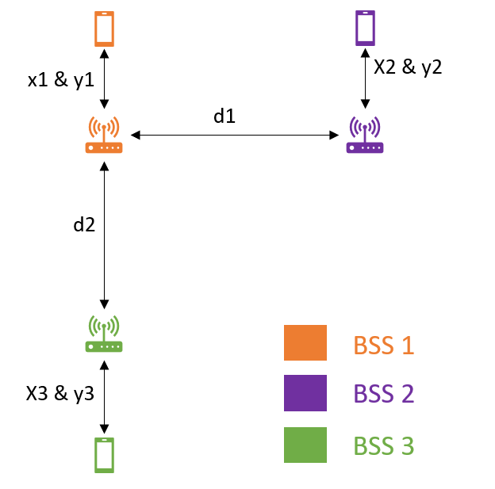
Figure 7. Spacing and distance parameters between AP and STA devices of each BSS in the main tests: tests 1, 2, 3, 4. Spacing between devices are determined by positioning parameters shown in the figure.

Main test simulations APs and STAs parameters
Parameter | Value
STA power (dBm) | 12
AP power (dBm) | 20
CCA for STAs & APs (dBm) | -82
Channel Bandwidth (MHz) | 40 (5GHz band)
BSS colouring enabled? | TRUE (Tests 1 & 3) / FALSE (Tests 2 & 4)
OBSS PD threshold (dBm) | -73
Payload size (bytes) | 1500 bytes (Default)
Distance between APs | 10m
STA distance from APs | 4m (Tests 1 & 2) / 5m (Tests 3 & 4)
Simulation run time | 10 seconds (default)
Table 2. Simulation test parameters for the main tests: tests 1, 2, 3, 4.

5.1.1 Tests 1 & 2
Tests 1 and 2 positioned STAs to be close to one another to force the OBSSs scenario, while keeping within their respective residential square and being 4-meters away from their respective APs. APs remained 10-meters apart from each other, a visualisation of this can be seen in Figure 8. The grid co-ordinate parameters for STAs and APs which were used to execute both tests can be seen in Figure 9.
The simulation for tests 1 and 2 were run with respective commands and parameters for each test scenario within the terminal CLI, as seen in Figure 10 and Appendix D – Commands used in test simulations and result outputs. Test 1 was run with BSS colouring enabled with the “--enableObssPd=True” command, while test 2 had BSS colouring disabled with the “--enableObssPd=False” command. Unfortunately, due to challenges with the modified script used in these tests, only throughput results for BSSs 2 and 3 were generated, while BSS 1 did not return a result. Results generated for BSS 2 and BSS 3 were recorded into a spreadsheet.
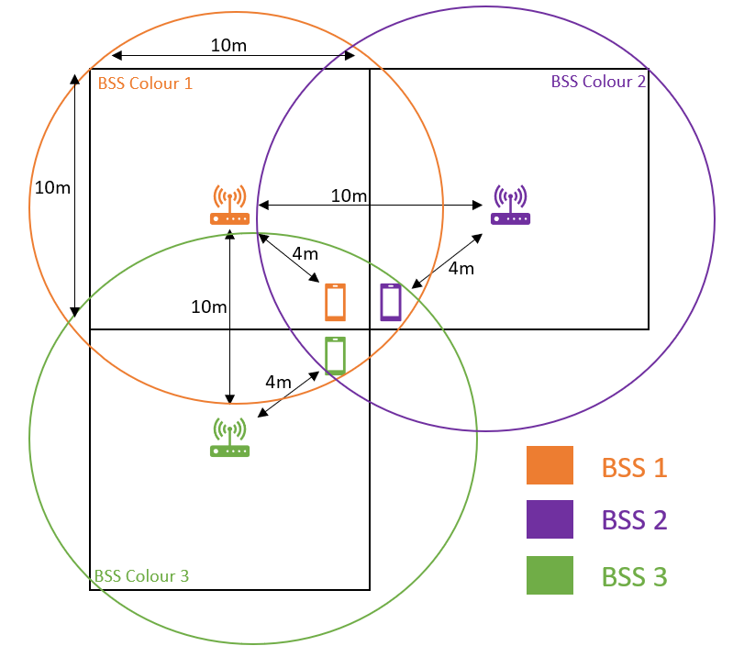
Figure 8. Diagram of simulation spacing set-up for main tests 1 & 2 in a residential environment scenario. STAs are positioned close together to force a OBSSs scenario, while staying in their respective BSS and residential square.
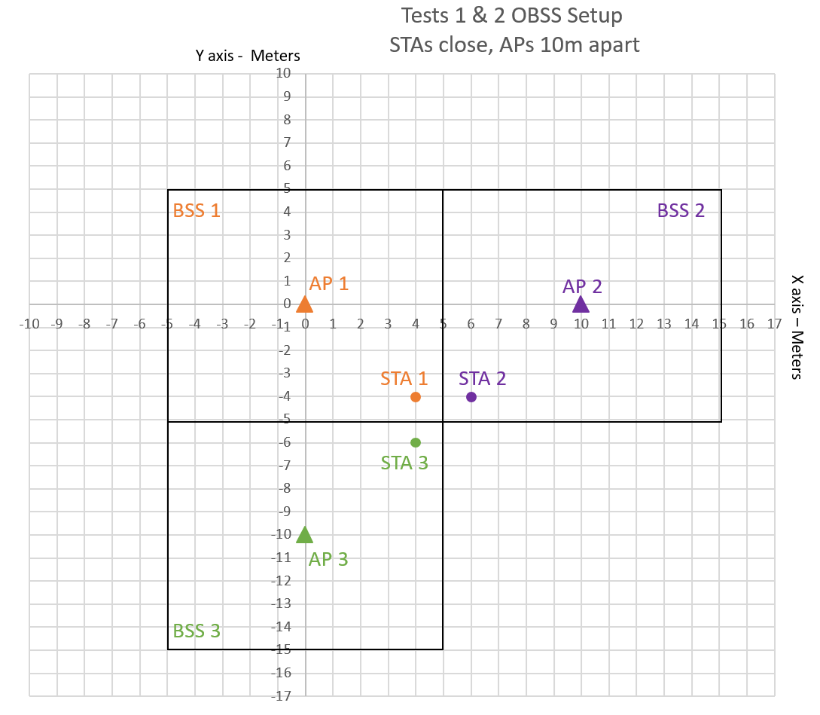
Figure 9. Grid co-ordinates visualisation for main tests 1 & 2 in a residential environment scenario. STAs are positioned close together to force a OBSSs scenario, while staying in their respective BSS and residential square.
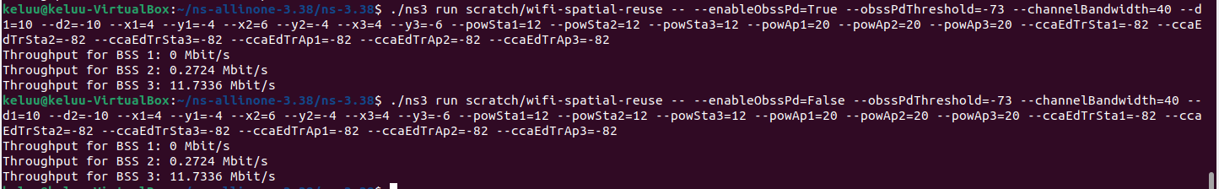
Figure 10. Main tests 1 & 2 NS3 simulations executed in the terminal CLI with generated results. BSS colouring is enabled in test 1 with "--enableObssPd=True" command, and BSS colouring disabled in test 2 with "--enableObssPd=False" command.

5.1.2 Tests 3 & 4
Tests 3 and 4 positioned STAs apart from each other and 5-meters away from their respective APs. APs remained 10-meters away from each other too, as seen in the visualisation in Figure 11. This scenario created a less harsh OBSSs environment compared to tests 1 and 2, to see if BSS colouring would make a difference in this scenario set-up. The grid co-ordinates parameters used to position STAs and APs when tests 3 and 4 were executed can be seen in Figure 12.
The respective commands used to run tests 3 and 4 can be seen in Figure 13 and Appendix D – Commands used in test simulations and result outputs. Test 3 was run with BSS colouring enabled with the “--enableObssPd=True” command, while test 4 had BSS colouring disabled with the “--enableObssPd=False” command. Again, due to challenges with the modified script, only throughput results for BSSs 2 and 3 were generated. Results generated for BSS 2 and BSS 3 were recorded into a spreadsheet.
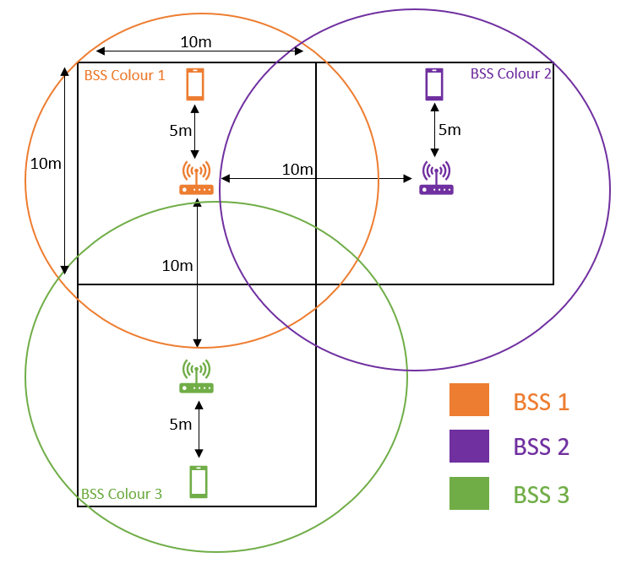
Figure 11. Diagram of simulation spacing set-up for main tests 3 & 4 in a residential environment scenario. STAs are positioned apart from each other to create a less harsh OBSSs scenario, while staying in their respective BSS and residential square.
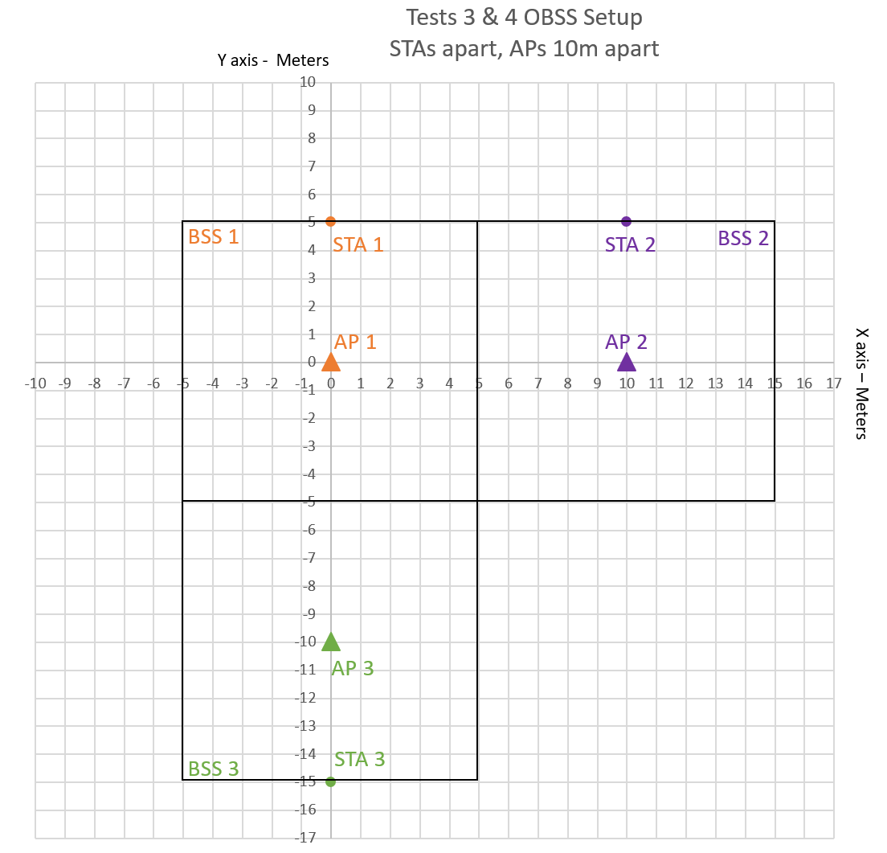
Figure 12. Grid co-ordinates visualisation for main tests 3 & 4 in a residential environment scenario. STAs are positioned apart from each other to create a less harsh OBSSs scenario, while staying in their respective BSS and residential square.
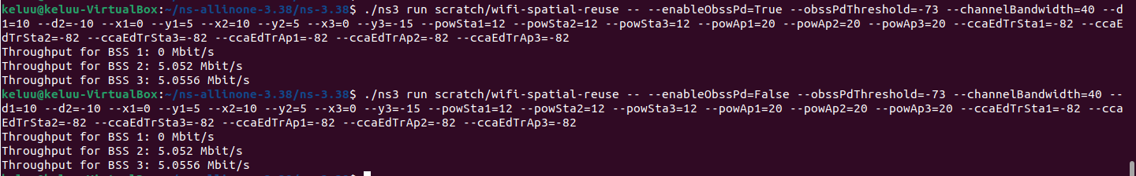
Figure 13. Main tests 3 & 4 NS3 simulations executed in the terminal CLI with generated results. BSS colouring is enabled in test 3 with "--enableObssPd=True" command, and BSS colouring disabled in test 3 with "--enableObssPd=False" command.

5.2 Sanity check tests – Tests 5, 6, 7, 8
A further four sanity check tests were run to cross reference and validate the results which were produced in the initial four main tests, as well as the reliability of the modified script that was used. The results which were produced in the main tests were surprising, they showed that BSS colouring made no difference to WLAN performance for the tightly packed residential scenario deployment. To validate the main test results, the sanity check tests, tests 5, 6, 7, and 8 were run using the original unmodified script, which can be seen in Appendix C – Original unmodified script. All sanity check tests were run using identical device transmit power and sensitivity parameters to the main test parameters, as seen in Table 3 below. Tests 5 and 6 replicated the positions and spacing between APs and STAs of tests 3 and 4. Tests 7 and 8 went beyond the conventional residential spacing parameters to further observe the WLAN performance behaviour for BSSs which had APs that were further apart. For the sanity check tests, only two BSSs were involved in the simulation tests; BSS 1 and BSS 2.
A visualisation of the positioning for APs and STAs in tests 5 & 6, and tests 7 & 8 can be seen in Figure 14. The grid co-ordinate positioning set-up for APs and STAs for the sanity check tests can be seen in Figure 15. All commands and parameters executed for the sanity check tests and all other tests can be found in Appendix D – Commands used in test simulations and result outputs.

Sanity check test simulations APs and STAs parameters
Parameter | Value
STA power (dBm) | 12
AP power (dBm) | 20
CCA for STAs & APs (dBm) | -82
Channel Bandwidth (MHz) | 40 (5GHz band)
BSS colouring enabled? | TRUE (Tests 5 & 7) / FALSE (Tests 6 & 8)
OBSS PD threshold (dBm) | -73
Payload size (bytes) | 1500 bytes (Default)
Distance between APs | 10m (Tests 5 & 6) / 75m (Tests 7 & 8)
STA distance from APs | 5m
Simulation run time | 10 seconds (Default)
Table 3. Simulation test parameters for the sanity check tests: tests 5, 6, 7, 8. All sanity check test parameters are identical to those use in the main tests: tests 3 & 4, apart from the AP distance in tests 7 & 8.

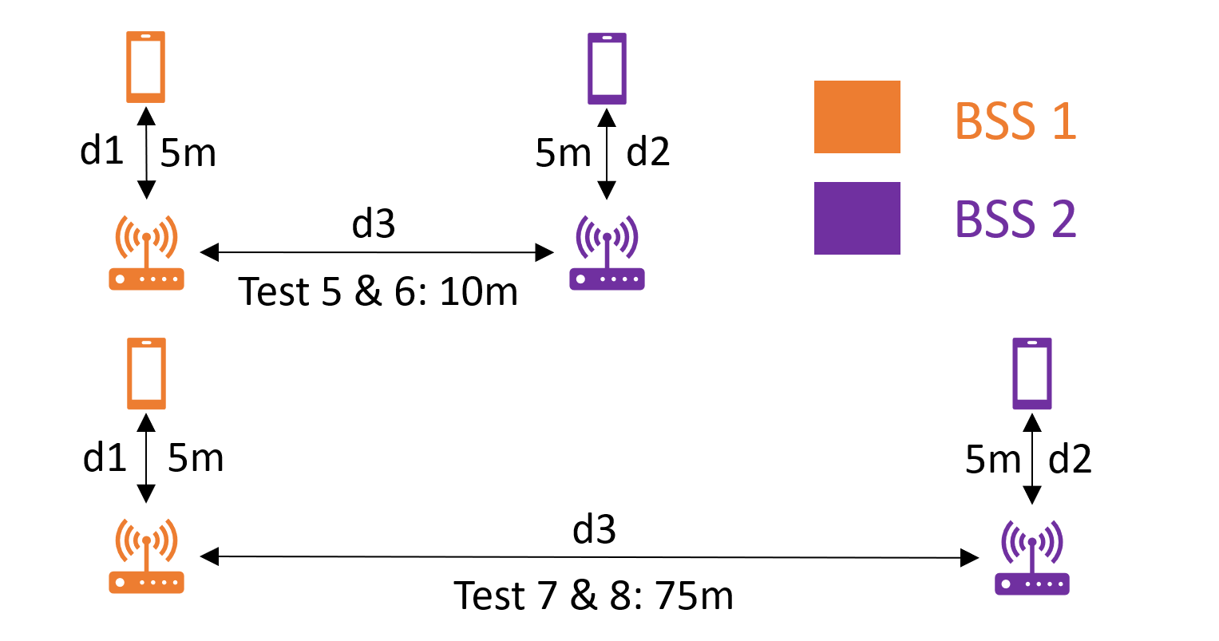
Figure 14. Diagram of simulation spacing set-up for sanity tests 5 & 6, and tests 7 & 8. Tests 5 & 6 follow conventional residential 10x10-meter square spacing parameters, tests 7 & 8 are 75m apart and beyond conventional parameters.

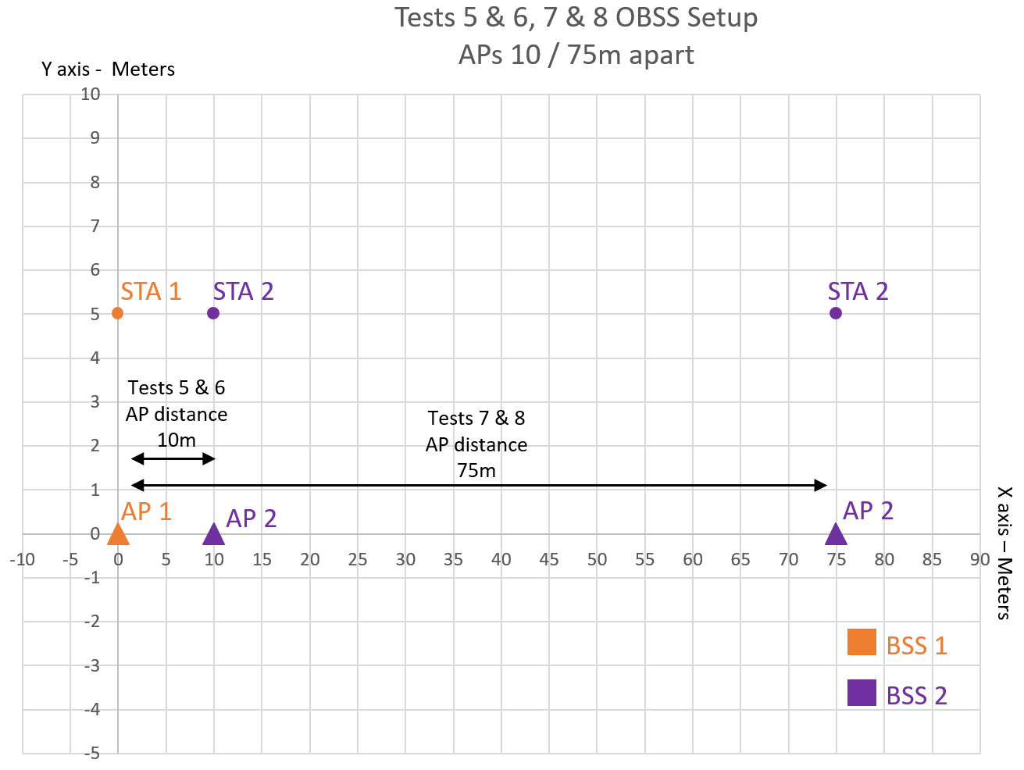
Figure 15. Grid co-ordinates visualisation for sanity check tests 5 & 6, and tests 7 & 8. Tests 5 & 6 follow conventional residential 10x10-meter square spacing parameters, tests 7 & 8 are 75m apart and beyond conventional parameters.

5.2.1 Tests 5 & 6
Tests 5 and 6 replicated the conventional residential 10-meter by 10-meter residential square APs and STAs positioning and spacing that was seen in tests 3 and 4. This time, the original unmodified script was used to run the sanity check tests as opposed to the modified script. The purpose of this scenario was to validate the residential WLAN connectivity behaviour, shown in the gathered results of the main tests, where BSS colouring was enabled and disabled. The original script had employed two BSSs in its base scenario deployment: BSS 1 and BSS 2. The distance between APs were 10-meters apart, with STAs 5-meters away from their respective AP, the grid co-ordinate positioning of this scenario set-up can be seen in Figure 15 above.
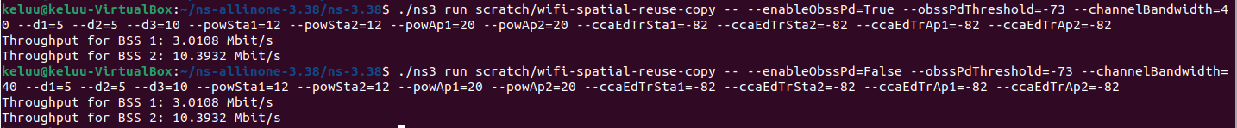
The commands which were run for tests 5 and 6 can be seen in Figure 16 and Appendix D – Commands used in test simulations and result outputs. Test 5 was run with BSS colouring enabled with the “--enableObssPd=True” command, while test 6 had BSS colouring disabled with the “--enableObssPd=False” command. Test 5 replicated the BSS colouring enabled scenario of test 3, while test 6 replicated the BSS colouring disabled scenario of test 4. Results generated for BSS 1 and BSS 2 were recorded into a spreadsheet.
Figure 16. Sanity check tests 5 & 6 NS3 simulations executed in the terminal CLI with generated results. BSS colouring is enabled in test 5 with "--enableObssPd=True" command, and BSS colouring disabled in test 6 with "--enableObssPd=False" command.

5.2.2 Tests 7 & 8
Tests 7 and 8 went beyond the conventional residential square spacing parameters, APs were spaced 75-meters apart and STAs were 5-meters away from their respective APs, the visualised grid co-ordinates positioning of this scenario can be seen in Figure 15. The original unmodified script was also used to run tests 7 and 8, again, only two BSSs were simulated: BSS 1 and BSS 2. With APs and STAs further apart compared to previous tests, this deployment scenario forced BSSs to be further apart so OBSSs and WLAN performance behaviour could be observed in this different scenario deployment.
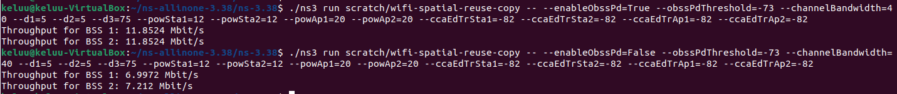
The commands which were run for tests 7 and 8 can be seen in Figure 17 and Appendix D – Commands used in test simulations and result outputs. Test 7 was run with BSS colouring enabled with the “--enableObssPd=True” command, while test 7 had BSS colouring disabled with the “--enableObssPd=False” command. Test 7 replicated the BSS colouring enabled scenario of tests 1, 3, and 5, while test 8 replicated the BSS colouring disabled scenario of tests 2, 4, and 6. Results generated for BSS 1 and BSS 2 were recorded into a spreadsheet.
Figure 17. Sanity check tests 7 & 8 NS3 simulations executed in the terminal CLI with generated results. BSS colouring is enabled in test 7 with "--enableObssPd=True" command, and BSS colouring disabled in test 8 with "--enableObssPd=False" command.

5.3 Problems that arose
There were several problems during the implementation of the project, specifically altering the code within the modified script. Due to these problems, the first task of scripting the simulator had taken the longest time compared to other tasks, and the current aim and research question of the project had changed from the original project, as mentioned in the 4.4.4 Deviation from original project aims section above. Most of the code modifications which did not work were left commented out in the modified script, as seen in Appendix B – Modified script.

5.3.1 The problems
The original idea to gather results from simulations was to generate an output file from when a simulation test was finished. NS3 offered two ways to do this, by using libraries such as Flow Monitor or Ascii trace within the modified script. Flow Monitor was the ideal solution to gather results as it offered granular data which includes the transmit and received throughput data for devices within the simulation, this data would have been outputted to an XML file (Nsnam, 2019). An additional python script would have been required to parse the collected data in the XML file to summarise the results. On the other hand, Ascii trace also produces an output file with granular information, but the file is not organised in a way which is easily readable or easily parsed for processing (Nsnam, 2019). Unfortunately, attempts to integrate Flow Monitor and Ascii trace into the modified script had broken the script and cryptic errors were produced when run in NS3.
Moreover, more than one STA device was attempted to be included into each BSS set-up in the modified script. However, in doing so, the script was broken slightly. The output result for BSS 1 failed to be generated when a simulation was run, because of this reason, only one STA device was set up for each BSS. With each BSS containing one STA, this matched the BSS set-ups within the original unmodified script.
In addition, a problem with the modified script was that it only outputted throughput results for two out of three BSSs; BSS 2 and BSS 3. Parameters of the simulation were altered multiple times to see if the values of the results that were able to be outputted changed, and they did. This proved that the simulation which utilised the modified script successfully ran, but for an unknown reason, results of BSS 1 were not displayed in the Linux terminal CLI.

5.3.2 Initial attempts to resolve problems
It was clear that the modified script had limitations. NS3 documentation of Flow Monitor and Ascii trace had been followed and consulted multiple times to try and resolve errors they produced. Multiple attempts were also made to resolve the limited BSS result outputs. Unfortunately, attempts to resolve these issues by following available NS3 documentation had failed. Additionally, a lot of time was spent on attempting to find if others had experienced the same issues and if they were resolved. However, probably due to the niche nature of NS3, similar problems or solutions by others were not found. Attempts at resolving these issues were the most time-consuming processes within the project.

5.3.3 Final attempts to resolve problems – Project supervisor meeting
In a final attempt to resolve all the issues mentioned, a meeting was set up with the project supervisor so that co-operation between them and the project member may try to resolve the issues. Unfortunately, after a lengthy meeting, no solution was found for attempting to implement Flow Monitor or Ascii trace, after consulting available documentation for them. Additionally, the issue for results only displayed for BSS 2 and BSS 3, and not BSS 1, as well as each BSS only able to house one STA, was also not resolved. This was likely due to limitations of the original script which was adopted and modified for the project. After efforts were exhausted at attempts to resolve these issues, it was agreed that the summarised throughput results for BSS 2 and BSS 3 produced after a simulation in the Linux terminal CLI were to be used for the project, so that the project may move forward. By the time of this meeting, the original project aim had updated to the current aims and research question presented in this report, due to the problems faced. The description of the original project can be seen in the 4.4.4 Deviation from original project aims section.

6. Results
The results gathered from all tests carried out in the project can be seen below in Table 4. Results for BSS 2 and BSS 3 were recorded from the main tests. Results for BSS 1 were not collected as the NS3 simulator failed to generate them, when the modified script was used. On the other hand, for the sanity check tests, results from BSS 1 and BSS 2 were recorded; the original script used for these tests only housed two BSSs. To visualise and summarise these results, bar charts were created so that the throughput behaviour of each set of tests could be evaluated.

 | Test results
 | BSS group | Throughput Mbit/s result
MAIN TESTS RESULTS | Test 1: STAs close and 4 meters away from APs, APs 10 meters apart  BSS colouring ENABLED
 | BSS 2 | 0.2724
 | BSS 3 | 11.7336
Test 2: STAs close and 4 meters away from APs, APs 10 meters apart
BSS colouring DISABLED
 | BSS 2 | 0.2724
 | BSS 3 | 11.7336
Test 3: STAs apart and 5 meters away from APs, APs 10 meters apart
BSS colouring ENABLED
 | BSS 2 | 5.052
 | BSS 3 | 5.0556
Test 4: STAs apart and 5 meters away from APs, APs 10 meters apart
BSS colouring DISABLED
 | BSS 2 | 5.052
 | BSS 3 | 5.0556
SANITY CHECK TESTS RESULTS | Test 5: STAs 5 meters away from APs, APs 10 meters apart  BSS colouring ENABLED
 | BSS 1 | 3.0108
 | BSS 2 | 10.3932
Test 6: STAs 5 meters away from APs, APs 10 meters apart
BSS colouring DISABLED
 | BSS 1 | 3.0108
 | BSS 2 | 10.3932
Test 7: STAs 5 meters away from APs, APs 10 meters apart
BSS colouring ENABLED
 | BSS 1 | 11.8524
 | BSS 2 | 11.8524
Test 8: STAs 5 meters away from APs, APs 10 meters apart
BSS colouring DISABLED
 | BSS 1 | 6.9972
 | BSS 2 | 7.212
Table 4. All results from project test simulations, main tests results and sanity check tests results.

6.1 Main tests results – Tests 1 & 2, tests 3 & 4
The main tests were run using the modified script created for the project, main test results were therefore produced by the modified script in NS3.

Tests 1 & 2 results summarisation and evaluation
The results for main tests 1 & 2 contradict the initial impression that BSS colouring would be a beneficial feature of Wi-Fi 6 for residential areas, as seen in the bar chart visualisation below in Figure 18. Tests 1 & 2 positioned STAs close together while staying within their residential square, as seen in Figure 8 above. The results show that BSS colouring made no difference to WLAN throughput performance regardless of if it was enabled or disabled in the close quarter positioning between STAs in their residential squares. Additionally, these results also point towards the competitive behaviour of BSSs which was discovered in the literature review by (Wilhelmi, et al., 2021), with BSS colouring enabled, one BSS would have a much greater performance to the other BSS. At least, this was the case for the close quarters residential area use case. Although, the same minimum maximum throughput behaviour between BSSs was observed with BSS colouring disabled too.

Figure 18. Bar chart displaying visualisation for results gathered in main tests 1 & 2, when STAs positioned close together. No difference in throughput performance with BSS colouring feature enabled or disabled, behaviour of BSSs have minimum maximum throughputs.

Tests 3 & 4 results summarisation and evaluation
Similarly, the results of main tests 3 & 4 also contradicted the initial impression that BSS colouring would be beneficial for residential WLAN throughput performance, as seen in the bar chart visualisation in Figure 19 below. Tests 3 & 4 positioned STAs of each BSS apart from each other, as seen in Figure 11 above. Again, even with the different positioning of STAs, the same trend of whether if BSS colouring was enabled or disabled made no difference to the throughput WLAN performance of the BSSs. However, with the STAs apart, there is no extreme minimum maximum throughput deviation and the throughput performance between the BSS 2 and BSS 3 is more stable, compared to tests 1 & 2. However, reiterating, BSS colouring being enabled or disabled had not made a difference to this more stable throughput performance.

Figure 19. Bar chart displaying visualisation for results gathered in main tests 3 & 4, when STAs positioned apart from each other. No difference in throughput performance with BSS colouring feature enabled or disabled, and behaviour of BSSs have the same throughputs.

6.2 Sanity check tests results – Tests 5 & 6, tests 7 & 8
Sanity check tests were run with the example original script before it was adopted and modified. Sanity check tests results were therefore produced by the original script in NS3, these results were cross referenced with the main tests results to validate them and the reliability of the modified script.

Tests 5 & 6 results summarisation and evaluation
The results of sanity check tests 5 & 6, once again contradict the impression that BSS colouring would be beneficial for residential WLAN performance, as seen in the bar chart visualisation in Figure 20. Tests 5 & 6 replicated the residential square spacing set-up of the main tests, as seen in Figure 14 above. Once again, the results produced with the replicated residential square spacing showed that whether BSS colouring was enabled or disabled, no difference was made to throughput performance of the BSSs. However, the extreme minimum and maximum throughputs can be observed again. More importantly, the replicated WLAN behaviour with BSS colouring not having an impact whether it was enabled or disabled validated the throughput behaviour witnessed in the main tests results. This indicates that within the close quarter environment of a residential environment, Wi-Fi 6 BSS colouring may not have a major beneficial impact to throughput performance.

Figure 20. Bar chart displaying visualisation for results gathered in sanity check tests 5 & 6, when STAs positioned 5m away from APs and APs 10m apart. No difference in throughput performance with BSS colouring feature enabled or disabled, behaviour of BSSs have minimum maximum throughputs.

Tests 7 & 8 results summarisation and evaluation
The results of sanity check tests 7 & 8, showed that the BSS colouring feature works when the set-up of BSSs were further apart from each other, as seen in the bar chart visualisation in Figure 21 below. Tests 7 & 8 went beyond the residential square spacing parameters and placed APs from each BSS 75-meters away from each other, while STAs were 5-meters away from their APs, as seen in Figure 14 above. The results show that when BSS colouring was enabled and BSSs further apart at 75-meters, there was a significant increase in throughput for both BSSs, around 4.64 Mbit/s to 4.85 Mbit/s more; a 64.34% to 69.38% increase in throughput compared to when BSS colouring was disabled. This shows that BSS colouring may not have an impactful benefit when deployed and enabled in a close quarter residential use case environment, shown from the previous test simulations at least. However, when APs and STAs from BSSs were further apart from each other, then BSS colouring finally had a positive impact on WLAN throughput performance, where throughput is increased from having BSS colouring enabled.

Figure 21. Bar chart displaying visualisation for results gathered in sanity check tests 5 & 6, when STAs positioned 5m away from APs and APs 75m apart. BSS colouring enabled when APs of BSSs placed further apart benefits throughput performance.

7. Conclusion
The NS3 simulations conducted in this project aimed to provide an answer to the research question: “To what extent would residential wireless local area network (WLAN) connectivity; throughput, be improved by the utilisation of BSS colouring derived from Wi-Fi 6 (IEEE 802.11ax)?”. The extent is that BSS colouring did not improve residential WLAN throughput performance. The end results reveal that BSS colouring did not have any additional performance benefits for WLAN performance of BSSs in a close quarter residential deployment, nor did it negatively impact WLAN performance. The trend of throughput behaviour for each BSS in the simulations remained identical regardless of if BSS colouring was enabled or disabled. Additionally, the competitive behaviour of minimum maximum WLAN performance could be observed in BSSs when STAs from each BSS were positioned close together to force the OBSS scenario, the performance of one BSS would thrive while the other suffered. On the other hand, when BSSs were placed far apart with APs 75-meters apart, beyond close quarter residential use case parameters, throughput for BSSs when BSS colouring was enabled had improved by up to 69.38%.
Although the results produced from the project provided an answer to the research question, they are inconclusive due to the problems faced in the project implementation. An example script provided by NS3 was modified for the project. While the modified script was able to be run in NS3, the script had numerous limitations. STA devices were limited to one per BSS which does not fully depict an ideal residential scenario, and only three BSSs were able to be scripted due to limitations of the adapted script. Additionally, no granular detailed result output file could be produced due to the limitations of the script, and of the results which were able to be generated; results were generated for two out of three BSSs. Due to these reasons, the simulation deployment scenarios ran with the modified script do not paint a full picture of an ideal residential use case or the full results, which paint the results as inconclusive.

8. Recommendations for further work
Should this project be pursued further or re-initiated, a different approach when utilising the NS3 simulator is needed to attempt to produce conclusive results. Due to complications with adapting an example script to modify it, it would be ideal to write an entirely new NS3 script that produces a fuller base scenario deployment for the residential use case. The script should ideally set up four BSSs which depict four residential squares; each housing a BSS, each BSS would then have multiple STAs, as this would likely be the case in the real world within a residential use case. However, the challenge of writing C++ code for the script persists, unless time is given to learn the coding language, or if additional members with the expertise are recruited and authorised for the project.
An entirely different approach would be to use real hardware within an anechoic chamber. An anechoic chamber is a specialised room which has the capability to block outside signals from reaching inside the room which interfere with experiments running within inside the chamber (National Institute of Standards and Technology, 2022). Existing research in wireless mobile technologies by (KOBAYASHI, et al., 2017) state that “an anechoic chamber may be applied to evaluate receiving characteristics of wireless mobile terminals as a simple evaluation environment”. This puts weight behind an anechoic chamber could perhaps be a point of interest, should the project be continued. However, the use of real hardware and an anechoic chamber would introduce financial and logistical challenges to the project.

References
Barrachina-Muñoz, S., Wilhelmi, F., Selinis, I. & Bellalta, B., 2019. Komondor: a Wireless Network Simulator for Next-Generation High-Density WLANs. Manchester, UK, s.n., pp. 1-8.
Available at: https://doi.org/10.1109/WD.2019.8734225

Deronne, S., 2019. wifi-spatial-reuse.cc. [Online]
Available at: https://github.com/nsnam/ns-3-dev-git/blob/master/examples/wireless/wifi-spatial-reuse.cc
[Accessed 20th April 2023].

Hoffman, C., 2017. How You and Your Neighbors Are Making Each Other’s Wi-Fi Worse (and What You Can Do About It). [Online]
Available at: https://www.howtogeek.com/209450/how-you-and-your-neighbors-are-making-each-other%E2%80%99s-wi-fi-worse-and-what-you-can-do-about-it/
[Accessed 23rd February 2023].

Kim, J. et al., 2013. Efficiency enhancement for dense WLAN environment. s.l., IEEE, p. 6.

KOBAYASHI, K., MURAYAMA, K., YASUDA, M. & SAEGUSA, K., 2017. Basic Study on the Anechoic Chamber for Receiver Evaluation of the Next Generation Wireless Communication Terminal. Electronics and Communications in Japan, 100(12), pp. 39-52.
Available at: https://doi.org/10.1002/ecj.12013

Kosek-Szott, K. et al., 2017. Coexistence Issues in Future Wi-Fi Networks. IEEE Network, Volume 31(4).
Available at: https://doi.org/10.1109/MNET.2017.1500284

Kumar, P., 2022. NS3 installation in Ubuntu | Complete Instructions. [Online]
Available at: https://www.youtube.com/watch?v=3lWeCGPiWWM
[Accessed 20th April 2023].

Lean, M., 2022. Benefits of high speed internet: case study research, s.l.: Building Digital UK.

Malhotra, A., Maity, M. & Dutta, A., 2019. How much can we reuse? An empirical analysis of the performance benefits achieved by spatial-reuse of IEEE 802.11ax. 2019 11th International Conference on Communication Systems & Networks (COMSNETS), Volume Jan 2019, 7-11, pp. 432-345.
Available at: https://doi.org/10.1109/COMSNETS.2019.8711404

Merlin, S. et al., 2015. TGax simulation scenarios. IEEE802, pp. 11-14.

National Institute of Standards and Technology, 2022. Spotlight: Getting Wireless Devices to Share the Radio Spectrum and Work in Harmony. [Online]
Available at: https://www.nist.gov/news-events/news/2022/07/spotlight-getting-wireless-devices-share-radio-spectrum-and-work-harmony
[Accessed 29th April 2023].

Natkaniec, M. & Bieryt, N., 2022. An analysis of BSS coloring mechanism in IEEE. INTL JOURNAL OF ELECTRONICS AND TELECOMMUNICATIONS, 68(4), pp. 855-862.
Available at: https://doi.org/10.24425/ijet.2022.143894
Nsnam, 2019. Flow Monitor. [Online]
Available at: https://www.nsnam.org/docs/models/html/flow-monitor.html
[Accessed 30th April 2023].

Nsnam, 2019. Tracing. [Online]
Available at: https://www.nsnam.org/docs/manual/html/tracing.html
[Accessed 25th April 2023].

Nsnam, 2023. Quick Start. [Online]
Available at: https://www.nsnam.org/docs/release/3.38/tutorial/html/quick-start.html#prerequisites
[Accessed 20th April 2023].

Nsnam, 2023. What is ns-3?. [Online]
Available at: https://www.nsnam.org/about/
[Accessed 20th April 2023].

Rachedi, A., Lohier, S., Cherrier, S. & Salhi, I., 2010. Wireless Network Simulators Relevance Compared to a Real Testbed in Outdoor and Indoor Environments. 6th International Wireless Communications and Mobile Computing Conference (IWCMC'10), 5(1).
Available at: https://doi.org/10.1145/1815396.1815477

Selinis, I., Katsaros, K., Vahid, S. & Tafazolli, R., 2018. Control OBSS/PD Sensitivity Threshold for IEEE 802.11ax BSS Color. 2018 IEEE 29th Annual International Symposium on Personal, Indoor and Mobile Radio Communications (PIMRC), pp. 1-7.
Available at: https://doi.org/10.1109/PIMRC.2018.8580778

TP-Link, 2023. Archer AX20. [Online]
Available at: https://www.tp-link.com/uk/home-networking/wifi-router/archer-ax20/#overview
[Accessed 25th April 2023].

TP-Link, 2023. Deco X50. [Online]
Available at: https://www.tp-link.com/uk/home-networking/deco/deco-x50/#overview
[Accessed 25th April 2023].

Wilhelmi, F. et al., 2021. Spatial Reuse in IEEE 802.11ax WLANs. Computer Communications, 170(0140-3664), pp. 65-83.
Available at: https://doi.org/10.1016/j.comcom.2021.01.028

Bibliography
Afaqui, S. M., Garcia-Villegas, E. & Lopez-Aguilera, E., 2017. IEEE 802.11ax: Challenges and Requirements for Future High Efficiency WiFi. IEEE Wireless Communications, 24(3), pp. 130-137.
Available at: https://doi.org/10.1109/MWC.2016.1600089WC
Ali, M. Z., Mišić, J. & Mišić, V. B., 2019. Bridging the Transition from IEEE 802.11ac to IEEE 802.11ax: Survival of EDCA in a Coexistence Environment. IEEE Network, Volume 33(3), pp. 102-107.
Available at: https://doi.org/10.1109/MNET.2019.1700224

Bardou, A., Begin, T. & Busson, A., 2022. Analysis of a Multi-Armed Bandit solution to improve the spatial reuse of next-generation WLANs. Computer Communications, 193(0140-3664), pp. 279-292.
Available at: https://doi.org/10.1016/j.comcom.2022.07.015

Behara, A. & Venkatesh, T., 2022. Performance Study of High-Efficiency IEEE 802.11ax WLAN Standard Using NS-3 Simulator. 2022 IEEE 27th International Workshop on Computer Aided Modeling and Design of Communication Links and Networks (CAMAD), pp. 226-231.
Available at: https://doi.org/10.1109/CAMAD55695.2022.9966905

Cisco, 2022. Wi-Fi 6 (802.11ax) Technical Guide. [Online]
Available at: https://documentation.meraki.com/MR/Wi-Fi_Basics_and_Best_Practices/Wi-Fi_6_(802.11ax)_Technical_Guide
[Accessed 15th March 2023].

Daldoul, Y., Meddour, D.-E. & Ksentini, A., 2020. Performance evaluation of OFDMA and MU-MIMO in 802.11ax networks. Computer Networks, Volume 182, p. 107477.
Available at: https://doi.org/10.1016/j.comnet.2020.107477

Epp, J., Jiang, C. & Zhang, Y. a., 2022. Performance Eveluation of Wi-Fi 6 with ns-3 and Analysis, Burnaby, BC, Canada: Simon Fraser University.

Jones, J., 2017. Wi-Fi 6 (802.11ax): 5 Things to Know. [Online]
Available at: https://www.qorvo.com/design-hub/blog/80211ax-5-things-to-know
[Accessed 8th May 2022].

Khorov, E., Kiryanov, A., Lyakhov, A. & Bianchi, G., 2019. A Tutorial on IEEE 802.11ax High Efficiency WLANs. IEEE Communications Surveys & Tutorials, Volume 21(1), pp. 1-20.
Available at: https://doi.org/10.1109/COMST.2018.2871099

Selinis, I. et al., 2016. Evaluation of the DSC algorithm and the BSS color scheme in dense cellular-like IEEE 802.11ax deployments. 2016 IEEE 27th Annual International Symposium on Personal, Indoor, and Mobile Radio Communications (PIMRC), pp. 1-7.
Available at: https://doi.org/10.1109/PIMRC.2016.7794832

Wang, K. & Psounis, K., 2020. Efficient scheduling and resource allocation in 802.11ax multi-user transmissions. Computer Communications, 152(0140-3664), pp. 171-186.
Available at: https://doi.org/10.1016/j.comcom.2020.01.010

Weinberg, N., 2018. What is 802.11ax (Wi-Fi 6), and what will it mean for 802.11ac. [Online]
Available at: https://www.networkworld.com/article/3258807/what-is-80211ax-wi-fi-6-and-what-will-it-mean-for-80211ac.html
[Accessed 8th May 2022].
Wu, J. & Jiang, T., 2014. A novel scheme to ease the problem of OBSS networks based on admission control and TPC. 2014 14th International Symposium on Communications and Information Technologies (ISCIT), pp. 558-592.
Available at: https://doi.org/10.1016/j.comcom.2020.01.010

Appendices

Appendix A – Ethics release
The ethics approval release for the project can be seen below.
The original project name: “Comparison of overlapping WiFi networks”, has been updated to the current project name: “Wi-Fi 6 BSS colouring for residential areas”, seen on the cover page of this report to be more concise and aligned to the dissertation project.

Appendix B – Modified script
The C++ code of the modified script used for the main NS3 simulations tests of the project; tests 1, 2, 3, 4, can be seen below in plain text. Modified and additional code added to the original script has “Modified code” comments added to them. The original script which was adopted and modified was written by (Deronne, 2019).
The modified script can also be found in the GitHub repository used for the project by clicking here, or by visiting the URL below.
Modified script GitHub repository URL: https://github.com/5luuk85/showcase_com616_dissertation_project/blob/65f52df7437546f095f0986c2a574917103e0db2/wifi-spatial-reuse.cc

// #################################### MODIFIED SCRIPT USED FOR DISSERTATION PROJECT COM616 ####################################
//
/* Copyright (c) 2019 University of Washington//
// This program is free software; you can redistribute it and/or modify
// it under the terms of the GNU General Public License version 2 as
// published by the Free Software Foundation;
//
// This program is distributed in the hope that it will be useful,
// but WITHOUT ANY WARRANTY; without even the implied warranty of
// MERCHANTABILITY or FITNESS FOR A PARTICULAR PURPOSE. See the
// GNU General Public License for more details.
//
// You should have received a copy of the GNU General Public License
// along with this program; if not, write to the Free Software
// Foundation, Inc., 59 Temple Place, Suite 330, Boston, MA 02111-1307 USA
//
// Author: Sébastien Deronne <sebastien.deronne@gmail.com>
//

//
// This example program can be used to experiment with spatial
// reuse mechanisms of 802.11ax.
//
// The geometry is as follows:
//
// STA1 STA2
// | |
// x1 & y1 | | x2 & y2
// | d1 |
// AP1 -----------AP2
// :
// d2 :
// :
// AP3
// |
// x3 & y3 |
// |
// STA3
//
// STA1 and AP1 are in one BSS (with color set to 1), while STA2 and AP2 are in
// another BSS (with color set to 2). The distances are configurable (d1 through d3).
//
// STA1 is continuously transmitting data to AP1, while STA2 is continuously sending data to AP2.
// Each STA has configurable traffic loads (inter packet interval and packet size).
// It is also possible to configure TX power per node as well as their CCA-ED tresholds.
// OBSS_PD spatial reuse feature can be enabled (default) or disabled, and the OBSS_PD
// threshold can be set as well (default: -72 dBm).
// A simple Friis path loss model is used and a constant PHY rate is considered.
//
// In general, the program can be configured at run-time by passing command-line arguments.
// The following command will display all of the available run-time help options:
// ./ns3 run "wifi-spatial-reuse --help"
//
// According to the Wi-Fi models of ns-3.36 release, throughput with
// OBSS PD enabled (--enableObssPd=True) was roughly 6.5 Mbps, and with
// it disabled (--enableObssPd=False) was roughly 3.5 Mbps.
//
// This difference between those results is because OBSS_PD spatial
// reuse enables to ignore transmissions from another BSS when the
// received power is below the configured threshold, and therefore
// either defer during ongoing transmission or transmit at the same
// time.
//
// Note that, by default, this script configures a network using a
// channel bandwidth of 20 MHz. Changing this value alone (through
// the --channelWidth argument) without properly adjusting other
// parameters will void the effect of spatial reuse: since energy is
// measured over the 20 MHz primary channel regardless of the channel
// width, doubling the transmission bandwidth creates a 3 dB drop in
// the measured energy level (i.e., a halving of the measured
// energy). Because of this, when using the channelWidth argument
// users should also adjust the CCA-ED Thresholds (via --ccaEdTrSta1,
// --ccaEdTrSta2, --ccaEdTrAp1, and --ccaEdTrAp2), the Minimum RSSI
// for preamble detection (via --minimumRssi), and the OBSS PD
// Threshold (via --obssPdThreshold) appropriately. For instance,
// this can be accomplished for a channel width of 40 MHz by lowering
// all these values by 3 dB compared to their defaults.
//
// In addition, consider that adapting the adjustments shown above
// for an 80 MHz bandwidth (using a 6 dB threshold adjustment instead
// of 3 dB) will not produce any changes when enableObssPd is enabled
// or disabled. The cause for this is the insufficient amount of
// traffic that is generated by default in the example: increasing
// the bandwidth shortens the frame durations, and lowers the
// collision probability. Collisions between BSSs are a necessary
// condition to see the improvements brought by spatial reuse, and
// thus increasing the amount of generated traffic by setting the
// interval argument to a lower value is necessary to see the
// benefits of spatial reuse in this scenario. This can, for
// instance, be accomplished by setting --interval=0.0001.
*/

#include "ns3/abort.h"
#include "ns3/ap-wifi-mac.h"
#include "ns3/application-container.h"
#include "ns3/command-line.h"
#include "ns3/config.h"
#include "ns3/double.h"
#include "ns3/he-configuration.h"
#include "ns3/mobility-helper.h"
#include "ns3/multi-model-spectrum-channel.h"
#include "ns3/packet-socket-client.h"
#include "ns3/packet-socket-helper.h"
#include "ns3/packet-socket-server.h"
#include "ns3/spectrum-wifi-helper.h"
#include "ns3/ssid.h"
#include "ns3/string.h"
#include "ns3/wifi-net-device.h"

// Added for Acsii trace - Modified, not used - failed to work
// #include "ns3/trace-helper.h"

// Added for Flow monitor - Modified, not used - failed to work
/* #include "ns3/flow-monitor.h"
#include "ns3/flow-monitor-helper.h"
*/

// Added for Netanim - Modified, not used
// #include "ns3/netanim-module.h"

using namespace ns3;

std::vector<uint32_t> bytesReceived(4);

uint32_t
ContextToNodeId(std::string context)
{
std::string sub = context.substr(10);
uint32_t pos = sub.find("/Device");
return std::stoi(sub.substr(0, pos));
}

void
SocketRx(std::string context, Ptr<const Packet> p, const Address& addr)
{
uint32_t nodeId = ContextToNodeId(context);
bytesReceived[nodeId] += p->GetSize();
}

int
main(int argc, char* argv[])
{
// The parameters of the simulation that can be changed
double duration = 10.0; // seconds

double d1 = 10.00; // meters - Modified code - Distance between AP1, AP2
double d2 = -10.00; // meters - Modified code - Distance between AP3, AP1
//double d6 = 10.00; // meters - Modified code, BSS 4 setup that fails to work
//double d7 = -15.00; // meters - Modified code, BSS 4 setup that fails to work
//double d8 = 15.00; // meters - Modified code, BSS 4 setup that fails to work

double x1 = 0.00; // meters - Modified code - X axis - Distance between STA 1, AP1
double x2 = 10.00; // meters - Modified code - X axis - Distance between STA 2, AP2
double x3 = 0.00; // meters - Modified code - X axis - Distance between STA 3, AP3

double y1 = 5.00; // meters - Modified code - Distance between STA 1, AP1
double y2 = 5.00; // meters - Modified code - Distance between STA 2, AP2
double y3 = -15.00; // meters - Modified code - Distance between STA 3, AP3

double powSta1 = 10.0; // dBm
double powSta2 = 10.0; // dBm
double powSta3 = 10.0; // dBm Modified code
//double powSta4 = 10.0; // dBm Modified code, BSS 4 setup that fails to work

double powAp1 = 21.0; // dBm
double powAp2 = 21.0; // dBm
double powAp3 = 21.0; // dBm Modified code
//double powAp4 = 21.0; // dBm Modified code, BSS 4 setup that fails to work

double ccaEdTrSta1 = -62; // dBm
double ccaEdTrSta2 = -62; // dBm
double ccaEdTrSta3 = -62; // dBm Modified code
//double ccaEdTrSta4 = -62; // dBm Modified code, BSS 4 setup that fails to work

double ccaEdTrAp1 = -62; // dBm
double ccaEdTrAp2 = -62; // dBm
double ccaEdTrAp3 = -62; // dBm Modified code
//double ccaEdTrAp4 = -62; // dBm Modified code, BSS 4 setup that fails to work

double minimumRssi = -82; // dBm
int channelBandwidth = 40; // MHz
uint32_t payloadSize = 1500; // bytes
uint32_t mcs = 0; // MCS value
double interval = 0.001; // seconds
bool enableObssPd = true; // Toggle sim BSS colouring on/off
double obssPdThreshold = -72.0; // dBm

// Terminal command line options to change parameters of simulation
CommandLine cmd(__FILE__);
cmd.AddValue("duration", "Duration of simulation (s)", duration);
cmd.AddValue("interval", "Inter packet interval (s)", interval);
cmd.AddValue("enableObssPd", "Enable/disable OBSS_PD", enableObssPd);
cmd.AddValue("d1", "Distance between AP1 and AP2 (m)", d1); // Modified code
cmd.AddValue("d2", "Distance between AP1 and AP3 (m)", d2); // Modified code
cmd.AddValue("y1", "Y axis distance between STA1 and AP1 (m)", y1); // Modified code
cmd.AddValue("y2", "Y axis distance between STA2 and AP2 (m)", y2); // Modified code
cmd.AddValue("y3", "Y axis distance between STA3 and AP3 (m)", y3); // Modified code
cmd.AddValue("x1", "X axis distance between STA1 and AP1 (m)", x1); // Modified code
cmd.AddValue("x2", "X axis distance between STA2 and AP2 (m)", x2); // Modified code
cmd.AddValue("x3", "X axis distance between STA3 and AP3 (m)", x3); // Modified code
// Distancec for AP 4 and STA 4 - Modified code, BBS 4 failed to work with script
/*
cmd.AddValue("d6", "Distance between AP3 and AP4 (m)", d6); // Modified code
cmd.AddValue("d7", "Distance between AP4 and AP2 (m)", d7); // Modified code
cmd.AddValue("d8", "Distance between STA4 and AP4 (m)", d8); // Modified code
*/

cmd.AddValue("powSta1", "Power of STA1 (dBm)", powSta1);
cmd.AddValue("powSta2", "Power of STA2 (dBm)", powSta2);
cmd.AddValue("powSta3", "Power of STA3 (dBm)", powSta3); // Modified code
//cmd.AddValue("powSta3", "Power of STA3 (dBm)", powSta4); // Modified code, BBS 4 failed to work with script

cmd.AddValue("powAp1", "Power of AP1 (dBm)", powAp1);
cmd.AddValue("powAp2", "Power of AP2 (dBm)", powAp2);
cmd.AddValue("powAp3", "Power of AP3 (dBm)", powAp3); // Modified code
//cmd.AddValue("powAp2", "Power of AP4 (dBm)", powAp4); // Modified code, BBS 4 failed to work with script

cmd.AddValue("ccaEdTrSta1", "CCA-ED Threshold of STA1 (dBm)", ccaEdTrSta1);
cmd.AddValue("ccaEdTrSta2", "CCA-ED Threshold of STA2 (dBm)", ccaEdTrSta2);
cmd.AddValue("ccaEdTrSta3", "CCA-ED Threshold of STA3 (dBm)", ccaEdTrSta3); // Modified code
//cmd.AddValue("ccaEdTrSta2", "CCA-ED Threshold of STA4 (dBm)", ccaEdTrSta4); // Modified code, BBS 4 failed to work with script

cmd.AddValue("ccaEdTrAp1", "CCA-ED Threshold of AP1 (dBm)", ccaEdTrAp1);
cmd.AddValue("ccaEdTrAp2", "CCA-ED Threshold of AP2 (dBm)", ccaEdTrAp2);
cmd.AddValue("ccaEdTrAp3", "CCA-ED Threshold of AP3 (dBm)", ccaEdTrAp3); // Modified code
//cmd.AddValue("ccaEdTrAp2", "CCA-ED Threshold of AP3 (dBm)", ccaEdTrAp4); // Modified code, BBS 4 failed to work with script
cmd.AddValue("minimumRssi",
"Minimum RSSI for the ThresholdPreambleDetectionModel",
minimumRssi);
cmd.AddValue("channelBandwidth",
"Bandwidth of the channel in MHz [20, 40, or 80]",
channelBandwidth);
cmd.AddValue("obssPdThreshold", "Threshold for the OBSS PD Algorithm", obssPdThreshold);
cmd.AddValue("mcs", "The constant MCS value to transmit HE PPDUs", mcs);
cmd.Parse(argc, argv);

// Create STA and AP nodes
NodeContainer wifiStaNodes;
wifiStaNodes.Create(3);

NodeContainer wifiApNodes;
wifiApNodes.Create(3);

// 5Ghz band and channel spectrum setup
SpectrumWifiPhyHelper spectrumPhy;
Ptr<MultiModelSpectrumChannel> spectrumChannel = CreateObject<MultiModelSpectrumChannel>();
Ptr<FriisPropagationLossModel> lossModel = CreateObject<FriisPropagationLossModel>();
spectrumChannel->AddPropagationLossModel(lossModel);
Ptr<ConstantSpeedPropagationDelayModel> delayModel =
CreateObject<ConstantSpeedPropagationDelayModel>();
spectrumChannel->SetPropagationDelayModel(delayModel);

spectrumPhy.SetChannel(spectrumChannel);
spectrumPhy.SetErrorRateModel("ns3::YansErrorRateModel");
switch (channelBandwidth)
{
case 20:
spectrumPhy.Set("ChannelSettings", StringValue("{36, 20, BAND_5GHZ, 0}"));
break;
case 40:
spectrumPhy.Set("ChannelSettings", StringValue("{62, 40, BAND_5GHZ, 0}"));
break;
case 80:
spectrumPhy.Set("ChannelSettings", StringValue("{171, 80, BAND_5GHZ, 0}"));
break;
default:
NS_ABORT_MSG("Unrecognized channel bandwidth: " << channelBandwidth);
break;
}
spectrumPhy.SetPreambleDetectionModel("ns3::ThresholdPreambleDetectionModel",
"MinimumRssi",
DoubleValue(minimumRssi));

// Set Wi-Fi 6 standard and include BSS colouring if enabled
WifiHelper wifi;
wifi.SetStandard(WIFI_STANDARD_80211ax);
if (enableObssPd)
{
wifi.SetObssPdAlgorithm("ns3::ConstantObssPdAlgorithm",
"ObssPdLevel",
DoubleValue(obssPdThreshold));

}

WifiMacHelper mac;
std::ostringstream oss;
oss << "HeMcs" << mcs;
wifi.SetRemoteStationManager("ns3::ConstantRateWifiManager",
"DataMode",
StringValue(oss.str()),
"ControlMode",
StringValue(oss.str()));

// BSS 1 properties and colouring setup
spectrumPhy.Set("TxPowerStart", DoubleValue(powSta1));
spectrumPhy.Set("TxPowerEnd", DoubleValue(powSta1));
spectrumPhy.Set("CcaEdThreshold", DoubleValue(ccaEdTrSta1));
spectrumPhy.Set("RxSensitivity", DoubleValue(-92.0));

Ssid ssidA = Ssid("A");
mac.SetType("ns3::StaWifiMac", "Ssid", SsidValue(ssidA));
NetDeviceContainer staDeviceA = wifi.Install(spectrumPhy, mac, wifiStaNodes.Get(0));

spectrumPhy.Set("TxPowerStart", DoubleValue(powAp1));
spectrumPhy.Set("TxPowerEnd", DoubleValue(powAp1));
spectrumPhy.Set("CcaEdThreshold", DoubleValue(ccaEdTrAp1));
spectrumPhy.Set("RxSensitivity", DoubleValue(-92.0));

mac.SetType("ns3::ApWifiMac", "Ssid", SsidValue(ssidA));
NetDeviceContainer apDeviceA = wifi.Install(spectrumPhy, mac, wifiApNodes.Get(0));

Ptr<WifiNetDevice> apDevice = apDeviceA.Get(0)->GetObject<WifiNetDevice>();
Ptr<ApWifiMac> apWifiMac = apDevice->GetMac()->GetObject<ApWifiMac>();
if (enableObssPd)
{
apDevice->GetHeConfiguration()->SetAttribute("BssColor", UintegerValue(1));
}

//BSS 2 properties and colouring setup
spectrumPhy.Set("TxPowerStart", DoubleValue(powSta2));
spectrumPhy.Set("TxPowerEnd", DoubleValue(powSta2));
spectrumPhy.Set("CcaEdThreshold", DoubleValue(ccaEdTrSta2));
spectrumPhy.Set("RxSensitivity", DoubleValue(-92.0));

Ssid ssidB = Ssid("B");
mac.SetType("ns3::StaWifiMac", "Ssid", SsidValue(ssidB));
NetDeviceContainer staDeviceB = wifi.Install(spectrumPhy, mac, wifiStaNodes.Get(1));

spectrumPhy.Set("TxPowerStart", DoubleValue(powAp2));
spectrumPhy.Set("TxPowerEnd", DoubleValue(powAp2));
spectrumPhy.Set("CcaEdThreshold", DoubleValue(ccaEdTrAp2));
spectrumPhy.Set("RxSensitivity", DoubleValue(-92.0));

mac.SetType("ns3::ApWifiMac", "Ssid", SsidValue(ssidB));
NetDeviceContainer apDeviceB = wifi.Install(spectrumPhy, mac, wifiApNodes.Get(1));

Ptr<WifiNetDevice> ap2Device = apDeviceB.Get(0)->GetObject<WifiNetDevice>();
apWifiMac = ap2Device->GetMac()->GetObject<ApWifiMac>();
if (enableObssPd)
{
ap2Device->GetHeConfiguration()->SetAttribute("BssColor", UintegerValue(2));
}

// BSS 3 properties and colouring setup - Modified code, added to original script
spectrumPhy.Set("TxPowerStart", DoubleValue(powSta3));
spectrumPhy.Set("TxPowerEnd", DoubleValue(powSta3));
spectrumPhy.Set("CcaEdThreshold", DoubleValue(ccaEdTrSta3));
spectrumPhy.Set("RxSensitivity", DoubleValue(-92.0));

Ssid ssidC = Ssid("C");
mac.SetType("ns3::StaWifiMac", "Ssid", SsidValue(ssidC));
NetDeviceContainer staDeviceC = wifi.Install(spectrumPhy, mac, wifiStaNodes.Get(2));

spectrumPhy.Set("TxPowerStart", DoubleValue(powAp3));
spectrumPhy.Set("TxPowerEnd", DoubleValue(powAp3));
spectrumPhy.Set("CcaEdThreshold", DoubleValue(ccaEdTrAp3));
spectrumPhy.Set("RxSensitivity", DoubleValue(-92.0));

mac.SetType("ns3::ApWifiMac", "Ssid", SsidValue(ssidC));
NetDeviceContainer apDeviceC = wifi.Install(spectrumPhy, mac, wifiApNodes.Get(2));

Ptr<WifiNetDevice> ap3Device = apDeviceC.Get(0)->GetObject<WifiNetDevice>();
apWifiMac = ap3Device->GetMac()->GetObject<ApWifiMac>();
if (enableObssPd)
{
ap3Device->GetHeConfiguration()->SetAttribute("BssColor", UintegerValue(3));
}

// BSS 4 properties and colouring setup - Modified code, failed to work, breaks script
/*
spectrumPhy.Set("TxPowerStart", DoubleValue(powSta4));
spectrumPhy.Set("TxPowerEnd", DoubleValue(powSta4));
spectrumPhy.Set("CcaEdThreshold", DoubleValue(ccaEdTrSta4));
spectrumPhy.Set("RxSensitivity", DoubleValue(-92.0));

Ssid ssidD = Ssid("D");
mac.SetType("ns3::StaWifiMac", "Ssid", SsidValue(ssidD));
NetDeviceContainer staDeviceD = wifi.Install(spectrumPhy, mac, wifiStaNodes.Get(3));

spectrumPhy.Set("TxPowerStart", DoubleValue(powAp4));
spectrumPhy.Set("TxPowerEnd", DoubleValue(powAp4));
spectrumPhy.Set("CcaEdThreshold", DoubleValue(ccaEdTrAp4));
spectrumPhy.Set("RxSensitivity", DoubleValue(-92.0));

mac.SetType("ns3::ApWifiMac", "Ssid", SsidValue(ssidD));
NetDeviceContainer apDeviceD = wifi.Install(spectrumPhy, mac, wifiApNodes.Get(3));

Ptr<WifiNetDevice> ap4Device = apDeviceD.Get(0)->GetObject<WifiNetDevice>();
apWifiMac = ap4Device->GetMac()->GetObject<ApWifiMac>();
if (enableObssPd)
{
ap3Device->GetHeConfiguration()->SetAttribute("BssColor", UintegerValue(4));
}
*/

// Mobility setup, grid positions of APs and STAs - PositionAlloc grid description (X axis, Y axis, Z axis )
MobilityHelper mobility;
Ptr<ListPositionAllocator> positionAlloc = CreateObject<ListPositionAllocator>();
positionAlloc->Add(Vector(0.0, 0.0, 0.0)); // AP1
positionAlloc->Add(Vector(d1, 0.0, 0.0)); // AP2
positionAlloc->Add(Vector(0.0, d2, 0.0)); // AP3 - Modified code, added to orginal script
//positionAlloc->Add(Vector(d6, d5, 0.0)); // AP4 - Modified code, failed to work

positionAlloc->Add(Vector(x1, y1, 0.0)); // STA1 - Modified code, added X&Y axis parameter
positionAlloc->Add(Vector(x2, y2, 0.0)); // STA2 - Modified code, added X&Y axis parameter
positionAlloc->Add(Vector(x3, y3, 0.0)); // STA3 - Modified code, added X&Y axis parameter
// positionAlloc->Add(Vector(d6, d8, 0.0)); // STA4 - Modified code, failed to work
mobility.SetMobilityModel("ns3::ConstantPositionMobilityModel");
mobility.SetPositionAllocator(positionAlloc);
mobility.Install(wifiApNodes); // Order of positions above will apply to AP nodes then STA nodes
mobility.Install(wifiStaNodes);

// Network Traffic setup
PacketSocketHelper packetSocket;
packetSocket.Install(wifiApNodes);
packetSocket.Install(wifiStaNodes);
ApplicationContainer apps;

// BSS 1 run setup
{
PacketSocketAddress socketAddr;
socketAddr.SetSingleDevice(staDeviceA.Get(0)->GetIfIndex());
socketAddr.SetPhysicalAddress(apDeviceA.Get(0)->GetAddress());
socketAddr.SetProtocol(1);
Ptr<PacketSocketClient> client = CreateObject<PacketSocketClient>();
client->SetRemote(socketAddr);
wifiStaNodes.Get(0)->AddApplication(client);
client->SetAttribute("PacketSize", UintegerValue(payloadSize));
client->SetAttribute("MaxPackets", UintegerValue(0));
client->SetAttribute("Interval", TimeValue(Seconds(interval)));
Ptr<PacketSocketServer> server = CreateObject<PacketSocketServer>();
server->SetLocal(socketAddr);
wifiApNodes.Get(0)->AddApplication(server);
}

// BSS 2 run setup
{
PacketSocketAddress socketAddr;
socketAddr.SetSingleDevice(staDeviceB.Get(0)->GetIfIndex());
socketAddr.SetPhysicalAddress(apDeviceB.Get(0)->GetAddress());
socketAddr.SetProtocol(1);
Ptr<PacketSocketClient> client = CreateObject<PacketSocketClient>();
client->SetRemote(socketAddr);
wifiStaNodes.Get(1)->AddApplication(client);
client->SetAttribute("PacketSize", UintegerValue(payloadSize));
client->SetAttribute("MaxPackets", UintegerValue(0));
client->SetAttribute("Interval", TimeValue(Seconds(interval)));
Ptr<PacketSocketServer> server = CreateObject<PacketSocketServer>();
server->SetLocal(socketAddr);
wifiApNodes.Get(1)->AddApplication(server);
}

// BSS 3 run setup - Modified code, added to original script
{
PacketSocketAddress socketAddr;
socketAddr.SetSingleDevice(staDeviceC.Get(0)->GetIfIndex());
socketAddr.SetPhysicalAddress(apDeviceC.Get(0)->GetAddress());
socketAddr.SetProtocol(1);
Ptr<PacketSocketClient> client = CreateObject<PacketSocketClient>();
client->SetRemote(socketAddr);
wifiStaNodes.Get(2)->AddApplication(client);
client->SetAttribute("PacketSize", UintegerValue(payloadSize));
client->SetAttribute("MaxPackets", UintegerValue(0));
client->SetAttribute("Interval", TimeValue(Seconds(interval)));
Ptr<PacketSocketServer> server = CreateObject<PacketSocketServer>();
server->SetLocal(socketAddr);
wifiApNodes.Get(2)->AddApplication(server);
}

// BSS 4 run setup - Modified code, failed to work and breaks script
/*
{
PacketSocketAddress socketAddr;
socketAddr.SetSingleDevice(staDeviceD.Get(0)->GetIfIndex());
socketAddr.SetPhysicalAddress(apDeviceD.Get(0)->GetAddress());
socketAddr.SetProtocol(1);
Ptr<PacketSocketClient> client = CreateObject<PacketSocketClient>();
client->SetRemote(socketAddr);
wifiStaNodes.Get(2)->AddApplication(client);
client->SetAttribute("PacketSize", UintegerValue(payloadSize));
client->SetAttribute("MaxPackets", UintegerValue(0));
client->SetAttribute("Interval", TimeValue(Seconds(interval)));
Ptr<PacketSocketServer> server = CreateObject<PacketSocketServer>();
server->SetLocal(socketAddr);
wifiApNodes.Get(3)->AddApplication(server);
}
*/

Config::Connect("/NodeList/*/ApplicationList/*/$ns3::PacketSocketServer/Rx",
MakeCallback(&SocketRx));

// Flow monitor initialise code - Modified code - Works but output file code failed
/*Ptr<FlowMonitor> flowMonitor;
FlowMonitorHelper flowHelper;
flowMonitor = flowHelper.InstallAll();
*/

Simulator::Stop(Seconds(duration));

// Netanim run - Modified code - used initailly to visualise positions of nodes, no longer used in code
/*
AnimationInterface anim("anim-spatical-reuse.xml");
anim.SetMaxPktsPerTraceFile(50000);
anim.SetConstantPosition(wifiApNodes.Get(0), 0.0, 0.0, 0.0); // AP 1
anim.SetConstantPosition(wifiApNodes.Get(1), d1, 0.0, 0.0); // AP 2
anim.SetConstantPosition(wifiApNodes.Get(2), 0.0, d2, 0.0); // AP 3
anim.SetConstantPosition(wifiApNodes.Get(2), d6, d7, 0.0); // AP 4

anim.SetConstantPosition(wifiStaNodes.Get(0), x1, y1, 0.0); // STA 1
anim.SetConstantPosition(wifiStaNodes.Get(1), x2, y2, 0.0); // STA 2
anim.SetConstantPosition(wifiStaNodes.Get(2), x3, y3, 0.0); // STA 3
anim.SetConstantPosition(wifiStaNodes.Get(2), d6, d8, 0.0); // STA 4
*/

// Ascii trace file output code - Modified code, failed to work and breaks script
/*AsciiTraceHelper ascii;
wifiStaNodes.EnableAsciiAll(ascii.CreateFileStream ("ascii-trace-spatial-reuse.tr"));
*/

Simulator::Run();

// Flow monitor output XML file line - modified code, failed to work and breaks script
//flowMonitor->SerializeToXmlFile("flowmonitor-wifi-spatial-reuse.xml", true, true);

Simulator::Destroy();

for (uint32_t i = 0; i < 3; i++) // Modified code - updated to output 3 sets of results generated for 3 BSSs in CLI
{
double throughput = static_cast<double>(bytesReceived[2 + i]) * 8 / 1000 / 1000 / duration;
std::cout << "Throughput for BSS " << i + 1 << ": " << throughput << " Mbit/s" << std::endl;
}

return 0;

}

Appendix C – Original unmodified script
The C++ code of the original script used for the sanity check NS3 simulations tests of the project; tests 5, 6, 7, 8, can be seen below in plain text. The original script is an example provided within the NS3 simulator and is written by (Deronne, 2019).
The original script can also be found in a forked GitHub repository used for the project by clicking here, or by visiting the URL below. Please note that minor changes to the original script in the GitHub repository may have been conducted by the NS3 community, but the core code remains the same.
Original script GitHub repository URL:
https://github.com/5luuk85/ns-3-dev-git-fork/blob/303113a80fdf89bc94d766bcd154545ac8da3a7b/examples/wireless/wifi-spatial-reuse.cc

/*
* Copyright (c) 2019 University of Washington
*
* This program is free software; you can redistribute it and/or modify
* it under the terms of the GNU General Public License version 2 as
* published by the Free Software Foundation;
*
* This program is distributed in the hope that it will be useful,
* but WITHOUT ANY WARRANTY; without even the implied warranty of
* MERCHANTABILITY or FITNESS FOR A PARTICULAR PURPOSE. See the
* GNU General Public License for more details.
*
* You should have received a copy of the GNU General Public License
* along with this program; if not, write to the Free Software
* Foundation, Inc., 59 Temple Place, Suite 330, Boston, MA 02111-1307 USA
*
* Author: Sébastien Deronne <sebastien.deronne@gmail.com>
*/

//
// This example program can be used to experiment with spatial
// reuse mechanisms of 802.11ax.
//
// The geometry is as follows:
//
// STA1 STA1
// | |
// d1 | |d2
// | d3 |
// AP1 -----------AP2
//
// STA1 and AP1 are in one BSS (with color set to 1), while STA2 and AP2 are in
// another BSS (with color set to 2). The distances are configurable (d1 through d3).
//
// STA1 is continuously transmitting data to AP1, while STA2 is continuously sending data to AP2.
// Each STA has configurable traffic loads (inter packet interval and packet size).
// It is also possible to configure TX power per node as well as their CCA-ED tresholds.
// OBSS_PD spatial reuse feature can be enabled (default) or disabled, and the OBSS_PD
// threshold can be set as well (default: -72 dBm).
// A simple Friis path loss model is used and a constant PHY rate is considered.
//
// In general, the program can be configured at run-time by passing command-line arguments.
// The following command will display all of the available run-time help options:
// ./ns3 run "wifi-spatial-reuse --help"
//
// According to the Wi-Fi models of ns-3.36 release, throughput with
// OBSS PD enabled (--enableObssPd=True) was roughly 6.5 Mbps, and with
// it disabled (--enableObssPd=False) was roughly 3.5 Mbps.
//
// This difference between those results is because OBSS_PD spatial
// reuse enables to ignore transmissions from another BSS when the
// received power is below the configured threshold, and therefore
// either defer during ongoing transmission or transmit at the same
// time.
//
// Note that, by default, this script configures a network using a
// channel bandwidth of 20 MHz. Changing this value alone (through
// the --channelWidth argument) without properly adjusting other
// parameters will void the effect of spatial reuse: since energy is
// measured over the 20 MHz primary channel regardless of the channel
// width, doubling the transmission bandwidth creates a 3 dB drop in
// the measured energy level (i.e., a halving of the measured
// energy). Because of this, when using the channelWidth argument
// users should also adjust the CCA-ED Thresholds (via --ccaEdTrSta1,
// --ccaEdTrSta2, --ccaEdTrAp1, and --ccaEdTrAp2), the Minimum RSSI
// for preamble detection (via --minimumRssi), and the OBSS PD
// Threshold (via --obssPdThreshold) appropriately. For instance,
// this can be accomplished for a channel width of 40 MHz by lowering
// all these values by 3 dB compared to their defaults.
//
// In addition, consider that adapting the adjustments shown above
// for an 80 MHz bandwidth (using a 6 dB threshold adjustment instead
// of 3 dB) will not produce any changes when enableObssPd is enabled
// or disabled. The cause for this is the insufficient amount of
// traffic that is generated by default in the example: increasing
// the bandwidth shortens the frame durations, and lowers the
// collision probability. Collisions between BSSs are a necessary
// condition to see the improvements brought by spatial reuse, and
// thus increasing the amount of generated traffic by setting the
// interval argument to a lower value is necessary to see the
// benefits of spatial reuse in this scenario. This can, for
// instance, be accomplished by setting --interval=0.0001.
//

#include "ns3/abort.h"
#include "ns3/ap-wifi-mac.h"
#include "ns3/application-container.h"
#include "ns3/command-line.h"
#include "ns3/config.h"
#include "ns3/double.h"
#include "ns3/he-configuration.h"
#include "ns3/mobility-helper.h"
#include "ns3/multi-model-spectrum-channel.h"
#include "ns3/packet-socket-client.h"
#include "ns3/packet-socket-helper.h"
#include "ns3/packet-socket-server.h"
#include "ns3/spectrum-wifi-helper.h"
#include "ns3/ssid.h"
#include "ns3/string.h"
#include "ns3/wifi-net-device.h"

using namespace ns3;

std::vector<uint32_t> bytesReceived(4);

uint32_t
ContextToNodeId(std::string context)
{
std::string sub = context.substr(10);
uint32_t pos = sub.find("/Device");
return std::stoi(sub.substr(0, pos));
}

void
SocketRx(std::string context, Ptr<const Packet> p, const Address& addr)
{
uint32_t nodeId = ContextToNodeId(context);
bytesReceived[nodeId] += p->GetSize();
}

int
main(int argc, char* argv[])
{
double duration = 10.0; // seconds
double d1 = 30.0; // meters
double d2 = 30.0; // meters
double d3 = 150.0; // meters
double powSta1 = 10.0; // dBm
double powSta2 = 10.0; // dBm
double powAp1 = 21.0; // dBm
double powAp2 = 21.0; // dBm
double ccaEdTrSta1 = -62; // dBm
double ccaEdTrSta2 = -62; // dBm
double ccaEdTrAp1 = -62; // dBm
double ccaEdTrAp2 = -62; // dBm
double minimumRssi = -82; // dBm
int channelBandwidth = 40; // MHz
uint32_t payloadSize = 1500; // bytes
uint32_t mcs = 0; // MCS value
double interval = 0.001; // seconds
bool enableObssPd = true;
double obssPdThreshold = -72.0; // dBm

CommandLine cmd(__FILE__);
cmd.AddValue("duration", "Duration of simulation (s)", duration);
cmd.AddValue("interval", "Inter packet interval (s)", interval);
cmd.AddValue("enableObssPd", "Enable/disable OBSS_PD", enableObssPd);
cmd.AddValue("d1", "Distance between STA1 and AP1 (m)", d1);
cmd.AddValue("d2", "Distance between STA2 and AP2 (m)", d2);
cmd.AddValue("d3", "Distance between AP1 and AP2 (m)", d3);
cmd.AddValue("powSta1", "Power of STA1 (dBm)", powSta1);
cmd.AddValue("powSta2", "Power of STA2 (dBm)", powSta2);
cmd.AddValue("powAp1", "Power of AP1 (dBm)", powAp1);
cmd.AddValue("powAp2", "Power of AP2 (dBm)", powAp2);
cmd.AddValue("ccaEdTrSta1", "CCA-ED Threshold of STA1 (dBm)", ccaEdTrSta1);
cmd.AddValue("ccaEdTrSta2", "CCA-ED Threshold of STA2 (dBm)", ccaEdTrSta2);
cmd.AddValue("ccaEdTrAp1", "CCA-ED Threshold of AP1 (dBm)", ccaEdTrAp1);
cmd.AddValue("ccaEdTrAp2", "CCA-ED Threshold of AP2 (dBm)", ccaEdTrAp2);
cmd.AddValue("minimumRssi",
"Minimum RSSI for the ThresholdPreambleDetectionModel",
minimumRssi);
cmd.AddValue("channelBandwidth",
"Bandwidth of the channel in MHz [20, 40, or 80]",
channelBandwidth);
cmd.AddValue("obssPdThreshold", "Threshold for the OBSS PD Algorithm", obssPdThreshold);
cmd.AddValue("mcs", "The constant MCS value to transmit HE PPDUs", mcs);
cmd.Parse(argc, argv);

NodeContainer wifiStaNodes;
wifiStaNodes.Create(2);

NodeContainer wifiApNodes;
wifiApNodes.Create(2);

SpectrumWifiPhyHelper spectrumPhy;
Ptr<MultiModelSpectrumChannel> spectrumChannel = CreateObject<MultiModelSpectrumChannel>();
Ptr<FriisPropagationLossModel> lossModel = CreateObject<FriisPropagationLossModel>();
spectrumChannel->AddPropagationLossModel(lossModel);
Ptr<ConstantSpeedPropagationDelayModel> delayModel =
CreateObject<ConstantSpeedPropagationDelayModel>();
spectrumChannel->SetPropagationDelayModel(delayModel);

spectrumPhy.SetChannel(spectrumChannel);
spectrumPhy.SetErrorRateModel("ns3::YansErrorRateModel");
switch (channelBandwidth)
{
case 20:
spectrumPhy.Set("ChannelSettings", StringValue("{36, 20, BAND_5GHZ, 0}"));
break;
case 40:
spectrumPhy.Set("ChannelSettings", StringValue("{62, 40, BAND_5GHZ, 0}"));
break;
case 80:
spectrumPhy.Set("ChannelSettings", StringValue("{171, 80, BAND_5GHZ, 0}"));
break;
default:
NS_ABORT_MSG("Unrecognized channel bandwidth: " << channelBandwidth);
break;
}
spectrumPhy.SetPreambleDetectionModel("ns3::ThresholdPreambleDetectionModel",
"MinimumRssi",
DoubleValue(minimumRssi));

WifiHelper wifi;
wifi.SetStandard(WIFI_STANDARD_80211ax);
if (enableObssPd)
{
wifi.SetObssPdAlgorithm("ns3::ConstantObssPdAlgorithm",
"ObssPdLevel",
DoubleValue(obssPdThreshold));
}

WifiMacHelper mac;
std::ostringstream oss;
oss << "HeMcs" << mcs;
wifi.SetRemoteStationManager("ns3::ConstantRateWifiManager",
"DataMode",
StringValue(oss.str()),
"ControlMode",
StringValue(oss.str()));

spectrumPhy.Set("TxPowerStart", DoubleValue(powSta1));
spectrumPhy.Set("TxPowerEnd", DoubleValue(powSta1));
spectrumPhy.Set("CcaEdThreshold", DoubleValue(ccaEdTrSta1));
spectrumPhy.Set("RxSensitivity", DoubleValue(-92.0));

Ssid ssidA = Ssid("A");
mac.SetType("ns3::StaWifiMac", "Ssid", SsidValue(ssidA));
NetDeviceContainer staDeviceA = wifi.Install(spectrumPhy, mac, wifiStaNodes.Get(0));

spectrumPhy.Set("TxPowerStart", DoubleValue(powAp1));
spectrumPhy.Set("TxPowerEnd", DoubleValue(powAp1));
spectrumPhy.Set("CcaEdThreshold", DoubleValue(ccaEdTrAp1));
spectrumPhy.Set("RxSensitivity", DoubleValue(-92.0));

mac.SetType("ns3::ApWifiMac", "Ssid", SsidValue(ssidA));
NetDeviceContainer apDeviceA = wifi.Install(spectrumPhy, mac, wifiApNodes.Get(0));

Ptr<WifiNetDevice> apDevice = apDeviceA.Get(0)->GetObject<WifiNetDevice>();
Ptr<ApWifiMac> apWifiMac = apDevice->GetMac()->GetObject<ApWifiMac>();
if (enableObssPd)
{
apDevice->GetHeConfiguration()->SetAttribute("BssColor", UintegerValue(1));
}

spectrumPhy.Set("TxPowerStart", DoubleValue(powSta2));
spectrumPhy.Set("TxPowerEnd", DoubleValue(powSta2));
spectrumPhy.Set("CcaEdThreshold", DoubleValue(ccaEdTrSta2));
spectrumPhy.Set("RxSensitivity", DoubleValue(-92.0));

Ssid ssidB = Ssid("B");
mac.SetType("ns3::StaWifiMac", "Ssid", SsidValue(ssidB));
NetDeviceContainer staDeviceB = wifi.Install(spectrumPhy, mac, wifiStaNodes.Get(1));

spectrumPhy.Set("TxPowerStart", DoubleValue(powAp2));
spectrumPhy.Set("TxPowerEnd", DoubleValue(powAp2));
spectrumPhy.Set("CcaEdThreshold", DoubleValue(ccaEdTrAp2));
spectrumPhy.Set("RxSensitivity", DoubleValue(-92.0));

mac.SetType("ns3::ApWifiMac", "Ssid", SsidValue(ssidB));
NetDeviceContainer apDeviceB = wifi.Install(spectrumPhy, mac, wifiApNodes.Get(1));

Ptr<WifiNetDevice> ap2Device = apDeviceB.Get(0)->GetObject<WifiNetDevice>();
apWifiMac = ap2Device->GetMac()->GetObject<ApWifiMac>();
if (enableObssPd)
{
ap2Device->GetHeConfiguration()->SetAttribute("BssColor", UintegerValue(2));
}

MobilityHelper mobility;
Ptr<ListPositionAllocator> positionAlloc = CreateObject<ListPositionAllocator>();
positionAlloc->Add(Vector(0.0, 0.0, 0.0)); // AP1
positionAlloc->Add(Vector(d3, 0.0, 0.0)); // AP2
positionAlloc->Add(Vector(0.0, d1, 0.0)); // STA1
positionAlloc->Add(Vector(d3, d2, 0.0)); // STA2
mobility.SetMobilityModel("ns3::ConstantPositionMobilityModel");
mobility.SetPositionAllocator(positionAlloc);
mobility.Install(wifiApNodes);
mobility.Install(wifiStaNodes);

PacketSocketHelper packetSocket;
packetSocket.Install(wifiApNodes);
packetSocket.Install(wifiStaNodes);
ApplicationContainer apps;

// BSS 1
{
PacketSocketAddress socketAddr;
socketAddr.SetSingleDevice(staDeviceA.Get(0)->GetIfIndex());
socketAddr.SetPhysicalAddress(apDeviceA.Get(0)->GetAddress());
socketAddr.SetProtocol(1);
Ptr<PacketSocketClient> client = CreateObject<PacketSocketClient>();
client->SetRemote(socketAddr);
wifiStaNodes.Get(0)->AddApplication(client);
client->SetAttribute("PacketSize", UintegerValue(payloadSize));
client->SetAttribute("MaxPackets", UintegerValue(0));
client->SetAttribute("Interval", TimeValue(Seconds(interval)));
Ptr<PacketSocketServer> server = CreateObject<PacketSocketServer>();
server->SetLocal(socketAddr);
wifiApNodes.Get(0)->AddApplication(server);
}

// BSS 2
{
PacketSocketAddress socketAddr;
socketAddr.SetSingleDevice(staDeviceB.Get(0)->GetIfIndex());
socketAddr.SetPhysicalAddress(apDeviceB.Get(0)->GetAddress());
socketAddr.SetProtocol(1);
Ptr<PacketSocketClient> client = CreateObject<PacketSocketClient>();
client->SetRemote(socketAddr);
wifiStaNodes.Get(1)->AddApplication(client);
client->SetAttribute("PacketSize", UintegerValue(payloadSize));
client->SetAttribute("MaxPackets", UintegerValue(0));
client->SetAttribute("Interval", TimeValue(Seconds(interval)));
Ptr<PacketSocketServer> server = CreateObject<PacketSocketServer>();
server->SetLocal(socketAddr);
wifiApNodes.Get(1)->AddApplication(server);
}

Config::Connect("/NodeList/*/ApplicationList/*/$ns3::PacketSocketServer/Rx",
MakeCallback(&SocketRx));

Simulator::Stop(Seconds(duration));
Simulator::Run();

Simulator::Destroy();

for (uint32_t i = 0; i < 2; i++)
{
double throughput = static_cast<double>(bytesReceived[2 + i]) * 8 / 1000 / 1000 / duration;
std::cout << "Throughput for BSS " << i + 1 << ": " << throughput << " Mbit/s" << std::endl;
}

return 0;
}

Appendix D – Commands used in test simulations and result outputs
The NS3 commands used for all tests to alter the simulation parameters depending on the test and their result output can be seen below in plain text.
The NS3 simulation tests commands used, and result outputs can also be found in the GitHub repository used for the project by clicking here, or by visiting the URL below.
NS3 simulation tests commands and results GitHub repository URL: https://github.com/5luuk85/showcase_com616_dissertation_project/blob/13a6c5ac5f2354f6dce0da3945c6522a690a02e8/NS3_commands_used_and_results.txt

Main tests – Commands aimed at answering the research question, ran by using modified script:
- Test 1  - Test 3 | - Test 2  - Test 4

Sanity check tests – Commands used to validate data gathered in main tests and modified script reliability, ran by using original unmodified script:
- Test 5  - Test 7 | - Test 6  - Test 8

---------------------------------- NS3 COMMANDS used and results ----------------------------------

##################### USED ON MODIFIED SCRIPT FOR MAIN TESTS #####################
Test 1
./ns3 run scratch/wifi-spatial-reuse -- --enableObssPd=True --obssPdThreshold=-73 --channelBandwidth=40 --d1=10 --d2=-10 --x1=4 --y1=-4 --x2=6 --y2=-4 --x3=4 --y3=-6 --powSta1=12 --powSta2=12 --powSta3=12 --powAp1=20 --powAp2=20 --powAp3=20 --ccaEdTrSta1=-82 --ccaEdTrSta2=-82 --ccaEdTrSta3=-82 --ccaEdTrAp1=-82 --ccaEdTrAp2=-82 --ccaEdTrAp3=-82
Throughput for BSS 1: 0 Mbit/s
Throughput for BSS 2: 0.2724 Mbit/s
Throughput for BSS 3: 11.7336 Mbit/s

Test 2
./ns3 run scratch/wifi-spatial-reuse -- --enableObssPd=False --obssPdThreshold=-73 --channelBandwidth=40 --d1=10 --d2=-10 --x1=4 --y1=-4 --x2=6 --y2=-4 --x3=4 --y3=-6 --powSta1=12 --powSta2=12 --powSta3=12 --powAp1=20 --powAp2=20 --powAp3=20 --ccaEdTrSta1=-82 --ccaEdTrSta2=-82 --ccaEdTrSta3=-82 --ccaEdTrAp1=-82 --ccaEdTrAp2=-82 --ccaEdTrAp3=-82
Throughput for BSS 1: 0 Mbit/s
Throughput for BSS 2: 0.2724 Mbit/s
Throughput for BSS 3: 11.7336 Mbit/s

Test 3
./ns3 run scratch/wifi-spatial-reuse -- --enableObssPd=True --obssPdThreshold=-73 --channelBandwidth=40 --d1=10 --d2=-10 --x1=0 --y1=5 --x2=10 --y2=5 --x3=0 --y3=-15 --powSta1=12 --powSta2=12 --powSta3=12 --powAp1=20 --powAp2=20 --powAp3=20 --ccaEdTrSta1=-82 --ccaEdTrSta2=-82 --ccaEdTrSta3=-82 --ccaEdTrAp1=-82 --ccaEdTrAp2=-82 --ccaEdTrAp3=-82
Throughput for BSS 1: 0 Mbit/s
Throughput for BSS 2: 5.052 Mbit/s
Throughput for BSS 3: 5.0556 Mbit/s

Test 4
./ns3 run scratch/wifi-spatial-reuse -- --enableObssPd=False --obssPdThreshold=-73 --channelBandwidth=40 --d1=10 --d2=-10 --x1=0 --y1=5 --x2=10 --y2=5 --x3=0 --y3=-15 --powSta1=12 --powSta2=12 --powSta3=12 --powAp1=20 --powAp2=20 --powAp3=20 --ccaEdTrSta1=-82 --ccaEdTrSta2=-82 --ccaEdTrSta3=-82 --ccaEdTrAp1=-82 --ccaEdTrAp2=-82 --ccaEdTrAp3=-82
Throughput for BSS 1: 0 Mbit/s
Throughput for BSS 2: 5.052 Mbit/s
Throughput for BSS 3: 5.0556 Mbit/s
##################### USED ON MODIFIED SCRIPT FOR MAIN TESTS #####################

##################### USED ON ORIGINAL SCRIPT FOR SANITY CHECK TESTS #################
Test 5
./ns3 run scratch/wifi-spatial-reuse-copy -- --enableObssPd=True --obssPdThreshold=-73 --channelBandwidth=40 --d1=5 --d2=5 --d3=10 --powSta1=12 --powSta2=12 --powAp1=20 --powAp2=20 --ccaEdTrSta1=-82 --ccaEdTrSta2=-82 --ccaEdTrAp1=-82 --ccaEdTrAp2=-82
Throughput for BSS 1: 3.0108 Mbit/s
Throughput for BSS 2: 10.3932 Mbit/s
Test 6
./ns3 run scratch/wifi-spatial-reuse-copy -- --enableObssPd=False --obssPdThreshold=-73 --channelBandwidth=40 --d1=5 --d2=5 --d3=10 --powSta1=12 --powSta2=12 --powAp1=20 --powAp2=20 --ccaEdTrSta1=-82 --ccaEdTrSta2=-82 --ccaEdTrAp1=-82 --ccaEdTrAp2=-82
Throughput for BSS 1: 3.0108 Mbit/s
Throughput for BSS 2: 10.3932 Mbit/s

Test 7
./ns3 run scratch/wifi-spatial-reuse-copy -- --enableObssPd=True --obssPdThreshold=-73 --channelBandwidth=40 --d1=5 --d2=5 --d3=75 --powSta1=12 --powSta2=12 --powAp1=20 --powAp2=20 --ccaEdTrSta1=-82 --ccaEdTrSta2=-82 --ccaEdTrAp1=-82 --ccaEdTrAp2=-82
Throughput for BSS 1: 11.8524 Mbit/s
Throughput for BSS 2: 11.8524 Mbit/s

Test 8
./ns3 run scratch/wifi-spatial-reuse-copy -- --enableObssPd=False --obssPdThreshold=-73 --channelBandwidth=40 --d1=5 --d2=5 --d3=75 --powSta1=12 --powSta2=12 --powAp1=20 --powAp2=20 --ccaEdTrSta1=-82 --ccaEdTrSta2=-82 --ccaEdTrAp1=-82 --ccaEdTrAp2=-82
Throughput for BSS 1: 6.9972 Mbit/s
Throughput for BSS 2: 7.212 Mbit/s
##################### USED ON ORIGINAL SCRIPT FOR SANITY CHECK TESTS #################

